**WORKBOOK**

for

**BILINGUAL CLASSICS in FRENCH**

The Secret Garden

by Frances Hodgson Burnett

Abridged and Translated by

**Christopher Dylan**

# Workbook Instructions

This workbook is designed to help you learn French using an abridged and translated version of the book The Secret Garden by Frances Hodgson Burnett along with its complementary audiobook.

The exercises below include listening, reading, and speaking activities that should be used for each chapter.

Listen to the chapter in English. Use the book to follow along in French. Slow the audio down if necessary. Beginners should listen to a paragraph at a time.

Listen to the chapter in French. Use the book to follow along in French. Slow the audio down if necessary. Beginners should listen to a paragraph at a time.

Read each sentence in French and see if you can comprehend the meaning. Words you need to look-up should be added to the chapter specific table later in the workbook.

Listen to each sentence in French and see if you can comprehend the meaning. Slow the audio down if necessary. Words you need to look-up should be added to the chapter specific table later in the workbook.

Listen to each sentence in French and read it aloud from the book. Slow the audio down if necessary. Try to emulate the intonations you hear. Record yourself speaking the sentences in French and listen to the recordings. Repeat this process until you can speak the sentences fluently without needing to read them from the book.

Ideally you should be able to comprehend the whole chapter while reading or listening to French, without referencing the English, before moving on to the next chapter.

Use the following LLM prompt to create fun visualisations for the '{french_word_you_need_to_memorise}'. Paste the response into a document for later review and to help reenforce the visualisations. Keep them in alphabetical order to avoid multiple visualisations for the same word, as these will just lead to confusion.

LLM PROMPT: "Create a visualisation in English for the French word '{french_word_you_need_to_memorise}' that will help me remember it both from English to French and French to English. The text should start with H3 '{French_WORD} <--> [{ENGLISH_WORD_LIST}]: {VISUALISATION_TITLE}' e.g. 'Langue <--> [Tongue, Language]: A short witty title'. This is followed by a graphic visualisation that is creative, fun, engaging, and memorable. Use phonetic wordplay if possible. It should include the meaning of the word in English and any relevant context or associations that will help me understand and remember the word. Respond with text that can be directly pasted into a workbook: no preamble or commentary, just the Visualisation text."

# Chapter 1.1

Write down any words you need to memorise in the table below. Revisit the list regularly and use each column to tick off the words you have learned in that session. Use the visualisation LLM prompt at the start of the workbook and the 'method of loci' to help imprint the words in your memory. Try writing the words in sentences to help you remember them better.

|  |  |  |  |  |  |  |  |  |  |  |  |  |  |
| --- | --- | --- | --- | --- | --- | --- | --- | --- | --- | --- | --- | --- | --- |
| Word To Learn | ☑ | ☑ | ☑ | ☑ | ☑ | ☑ | ☑ | ☑ | ☑ | ☑ | ☑ | ☑ | ☑ |
|  |  |  |  |  |  |  |  |  |  |  |  |  |  |
|  |  |  |  |  |  |  |  |  |  |  |  |  |  |
|  |  |  |  |  |  |  |  |  |  |  |  |  |  |
|  |  |  |  |  |  |  |  |  |  |  |  |  |  |
|  |  |  |  |  |  |  |  |  |  |  |  |  |  |
|  |  |  |  |  |  |  |  |  |  |  |  |  |  |
|  |  |  |  |  |  |  |  |  |  |  |  |  |  |
|  |  |  |  |  |  |  |  |  |  |  |  |  |  |
|  |  |  |  |  |  |  |  |  |  |  |  |  |  |
|  |  |  |  |  |  |  |  |  |  |  |  |  |  |
|  |  |  |  |  |  |  |  |  |  |  |  |  |  |
|  |  |  |  |  |  |  |  |  |  |  |  |  |  |
|  |  |  |  |  |  |  |  |  |  |  |  |  |  |
|  |  |  |  |  |  |  |  |  |  |  |  |  |  |
|  |  |  |  |  |  |  |  |  |  |  |  |  |  |
|  |  |  |  |  |  |  |  |  |  |  |  |  |  |
|  |  |  |  |  |  |  |  |  |  |  |  |  |  |
|  |  |  |  |  |  |  |  |  |  |  |  |  |  |
|  |  |  |  |  |  |  |  |  |  |  |  |  |  |
|  |  |  |  |  |  |  |  |  |  |  |  |  |  |
|  |  |  |  |  |  |  |  |  |  |  |  |  |  |
|  |  |  |  |  |  |  |  |  |  |  |  |  |  |
|  |  |  |  |  |  |  |  |  |  |  |  |  |  |
|  |  |  |  |  |  |  |  |  |  |  |  |  |  |
|  |  |  |  |  |  |  |  |  |  |  |  |  |  |
|  |  |  |  |  |  |  |  |  |  |  |  |  |  |
|  |  |  |  |  |  |  |  |  |  |  |  |  |  |
|  |  |  |  |  |  |  |  |  |  |  |  |  |  |
|  |  |  |  |  |  |  |  |  |  |  |  |  |  |
|  |  |  |  |  |  |  |  |  |  |  |  |  |  |
|  |  |  |  |  |  |  |  |  |  |  |  |  |  |
|  |  |  |  |  |  |  |  |  |  |  |  |  |  |
|  |  |  |  |  |  |  |  |  |  |  |  |  |  |
|  |  |  |  |  |  |  |  |  |  |  |  |  |  |
|  |  |  |  |  |  |  |  |  |  |  |  |  |  |
|  |  |  |  |  |  |  |  |  |  |  |  |  |  |
|  |  |  |  |  |  |  |  |  |  |  |  |  |  |
|  |  |  |  |  |  |  |  |  |  |  |  |  |  |
|  |  |  |  |  |  |  |  |  |  |  |  |  |  |
|  |  |  |  |  |  |  |  |  |  |  |  |  |  |
|  |  |  |  |  |  |  |  |  |  |  |  |  |  |
|  |  |  |  |  |  |  |  |  |  |  |  |  |  |
|  |  |  |  |  |  |  |  |  |  |  |  |  |  |
|  |  |  |  |  |  |  |  |  |  |  |  |  |  |
|  |  |  |  |  |  |  |  |  |  |  |  |  |  |
|  |  |  |  |  |  |  |  |  |  |  |  |  |  |
|  |  |  |  |  |  |  |  |  |  |  |  |  |  |
|  |  |  |  |  |  |  |  |  |  |  |  |  |  |
|  |  |  |  |  |  |  |  |  |  |  |  |  |  |

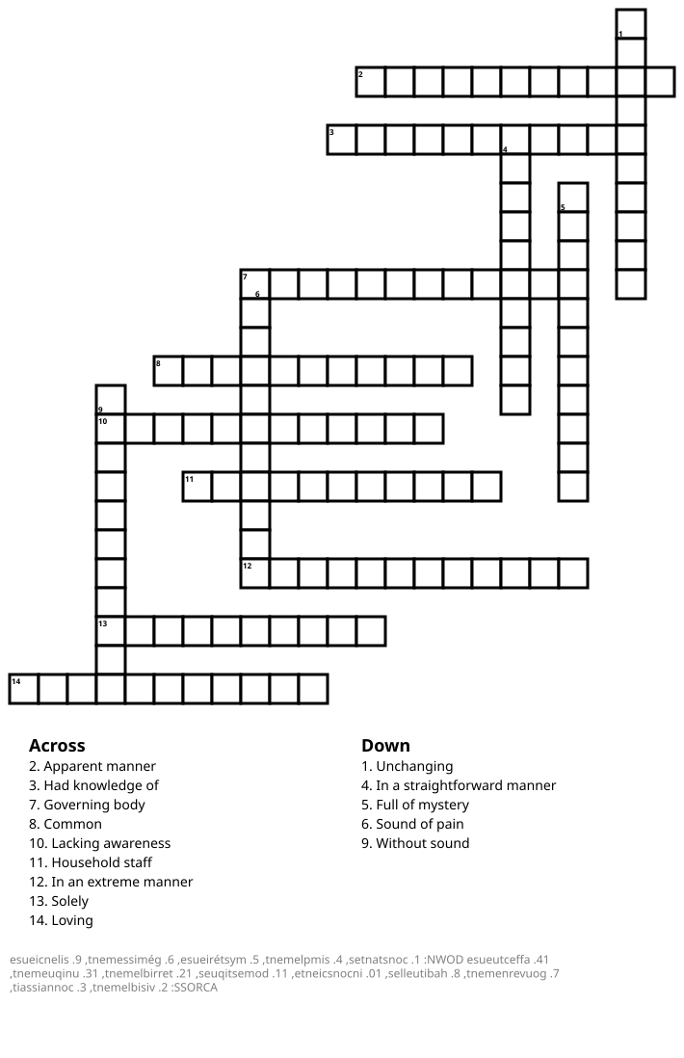

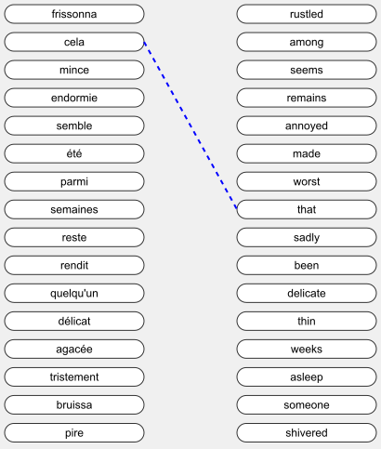

tsrow - erip ,deltsur - assiurb ,yldas - tnemetsirt ,deyonna - eécaga ,etaciled - taciléd ,enoemos - nu'uqleuq ,edam - tidner ,sniamer - etser ,skeew - seniames ,gnoma - imrap ,neeb - été ,smees - elbmes ,peelsa - eimrodne ,niht - ecnim ,taht - alec ,derevihs - annossirf

# Chapter 1.2

Write down any words you need to memorise in the table below. Revisit the list regularly and use each column to tick off the words you have learned in that session. Use the visualisation LLM prompt at the start of the workbook and the 'method of loci' to help imprint the words in your memory. Try writing the words in sentences to help you remember them better.

|  |  |  |  |  |  |  |  |  |  |  |  |  |  |
| --- | --- | --- | --- | --- | --- | --- | --- | --- | --- | --- | --- | --- | --- |
| Word To Learn | ☑ | ☑ | ☑ | ☑ | ☑ | ☑ | ☑ | ☑ | ☑ | ☑ | ☑ | ☑ | ☑ |
|  |  |  |  |  |  |  |  |  |  |  |  |  |  |
|  |  |  |  |  |  |  |  |  |  |  |  |  |  |
|  |  |  |  |  |  |  |  |  |  |  |  |  |  |
|  |  |  |  |  |  |  |  |  |  |  |  |  |  |
|  |  |  |  |  |  |  |  |  |  |  |  |  |  |
|  |  |  |  |  |  |  |  |  |  |  |  |  |  |
|  |  |  |  |  |  |  |  |  |  |  |  |  |  |
|  |  |  |  |  |  |  |  |  |  |  |  |  |  |
|  |  |  |  |  |  |  |  |  |  |  |  |  |  |
|  |  |  |  |  |  |  |  |  |  |  |  |  |  |
|  |  |  |  |  |  |  |  |  |  |  |  |  |  |
|  |  |  |  |  |  |  |  |  |  |  |  |  |  |
|  |  |  |  |  |  |  |  |  |  |  |  |  |  |
|  |  |  |  |  |  |  |  |  |  |  |  |  |  |
|  |  |  |  |  |  |  |  |  |  |  |  |  |  |
|  |  |  |  |  |  |  |  |  |  |  |  |  |  |
|  |  |  |  |  |  |  |  |  |  |  |  |  |  |
|  |  |  |  |  |  |  |  |  |  |  |  |  |  |
|  |  |  |  |  |  |  |  |  |  |  |  |  |  |
|  |  |  |  |  |  |  |  |  |  |  |  |  |  |
|  |  |  |  |  |  |  |  |  |  |  |  |  |  |
|  |  |  |  |  |  |  |  |  |  |  |  |  |  |
|  |  |  |  |  |  |  |  |  |  |  |  |  |  |
|  |  |  |  |  |  |  |  |  |  |  |  |  |  |
|  |  |  |  |  |  |  |  |  |  |  |  |  |  |
|  |  |  |  |  |  |  |  |  |  |  |  |  |  |
|  |  |  |  |  |  |  |  |  |  |  |  |  |  |
|  |  |  |  |  |  |  |  |  |  |  |  |  |  |
|  |  |  |  |  |  |  |  |  |  |  |  |  |  |
|  |  |  |  |  |  |  |  |  |  |  |  |  |  |
|  |  |  |  |  |  |  |  |  |  |  |  |  |  |
|  |  |  |  |  |  |  |  |  |  |  |  |  |  |
|  |  |  |  |  |  |  |  |  |  |  |  |  |  |
|  |  |  |  |  |  |  |  |  |  |  |  |  |  |
|  |  |  |  |  |  |  |  |  |  |  |  |  |  |
|  |  |  |  |  |  |  |  |  |  |  |  |  |  |
|  |  |  |  |  |  |  |  |  |  |  |  |  |  |
|  |  |  |  |  |  |  |  |  |  |  |  |  |  |
|  |  |  |  |  |  |  |  |  |  |  |  |  |  |
|  |  |  |  |  |  |  |  |  |  |  |  |  |  |
|  |  |  |  |  |  |  |  |  |  |  |  |  |  |
|  |  |  |  |  |  |  |  |  |  |  |  |  |  |
|  |  |  |  |  |  |  |  |  |  |  |  |  |  |
|  |  |  |  |  |  |  |  |  |  |  |  |  |  |
|  |  |  |  |  |  |  |  |  |  |  |  |  |  |
|  |  |  |  |  |  |  |  |  |  |  |  |  |  |
|  |  |  |  |  |  |  |  |  |  |  |  |  |  |
|  |  |  |  |  |  |  |  |  |  |  |  |  |  |
|  |  |  |  |  |  |  |  |  |  |  |  |  |  |

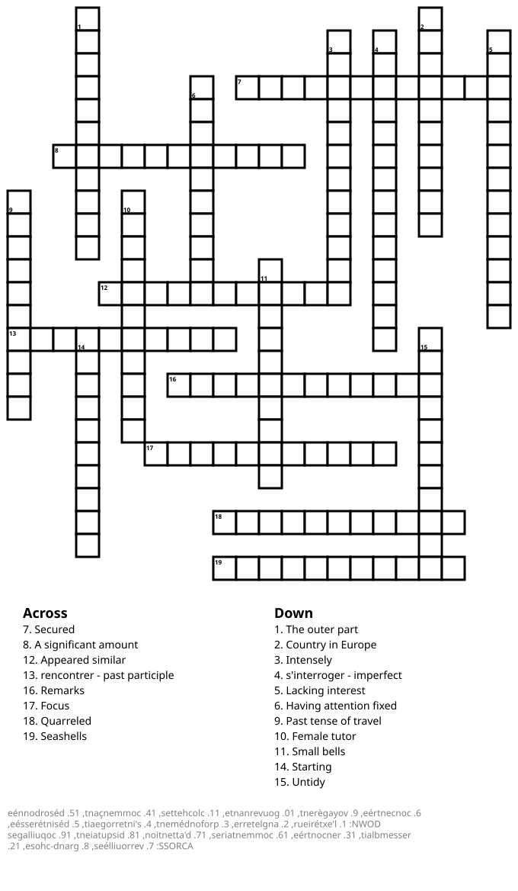

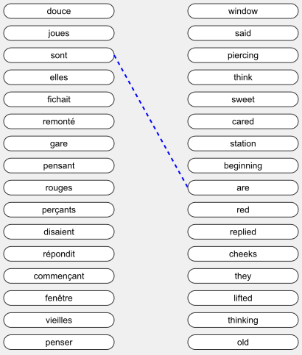

kniht - resnep ,dlo - sellieiv ,wodniw - ertênef ,gninnigeb - tnaçnemmoc ,deilper - tidnopér ,dias - tneiasid ,gnicreip - stnaçrep ,der - seguor ,gnikniht - tnasnep ,noitats - erag ,detfil - étnomer ,derac - tiahcif ,yeht - selle ,era - tnos ,skeehc - seuoj ,teews - ecuod

# Chapter 1.3

Write down any words you need to memorise in the table below. Revisit the list regularly and use each column to tick off the words you have learned in that session. Use the visualisation LLM prompt at the start of the workbook and the 'method of loci' to help imprint the words in your memory. Try writing the words in sentences to help you remember them better.

|  |  |  |  |  |  |  |  |  |  |  |  |  |  |
| --- | --- | --- | --- | --- | --- | --- | --- | --- | --- | --- | --- | --- | --- |
| Word To Learn | ☑ | ☑ | ☑ | ☑ | ☑ | ☑ | ☑ | ☑ | ☑ | ☑ | ☑ | ☑ | ☑ |
|  |  |  |  |  |  |  |  |  |  |  |  |  |  |
|  |  |  |  |  |  |  |  |  |  |  |  |  |  |
|  |  |  |  |  |  |  |  |  |  |  |  |  |  |
|  |  |  |  |  |  |  |  |  |  |  |  |  |  |
|  |  |  |  |  |  |  |  |  |  |  |  |  |  |
|  |  |  |  |  |  |  |  |  |  |  |  |  |  |
|  |  |  |  |  |  |  |  |  |  |  |  |  |  |
|  |  |  |  |  |  |  |  |  |  |  |  |  |  |
|  |  |  |  |  |  |  |  |  |  |  |  |  |  |
|  |  |  |  |  |  |  |  |  |  |  |  |  |  |
|  |  |  |  |  |  |  |  |  |  |  |  |  |  |
|  |  |  |  |  |  |  |  |  |  |  |  |  |  |
|  |  |  |  |  |  |  |  |  |  |  |  |  |  |
|  |  |  |  |  |  |  |  |  |  |  |  |  |  |
|  |  |  |  |  |  |  |  |  |  |  |  |  |  |
|  |  |  |  |  |  |  |  |  |  |  |  |  |  |
|  |  |  |  |  |  |  |  |  |  |  |  |  |  |
|  |  |  |  |  |  |  |  |  |  |  |  |  |  |
|  |  |  |  |  |  |  |  |  |  |  |  |  |  |
|  |  |  |  |  |  |  |  |  |  |  |  |  |  |
|  |  |  |  |  |  |  |  |  |  |  |  |  |  |
|  |  |  |  |  |  |  |  |  |  |  |  |  |  |
|  |  |  |  |  |  |  |  |  |  |  |  |  |  |
|  |  |  |  |  |  |  |  |  |  |  |  |  |  |
|  |  |  |  |  |  |  |  |  |  |  |  |  |  |
|  |  |  |  |  |  |  |  |  |  |  |  |  |  |
|  |  |  |  |  |  |  |  |  |  |  |  |  |  |
|  |  |  |  |  |  |  |  |  |  |  |  |  |  |
|  |  |  |  |  |  |  |  |  |  |  |  |  |  |
|  |  |  |  |  |  |  |  |  |  |  |  |  |  |
|  |  |  |  |  |  |  |  |  |  |  |  |  |  |
|  |  |  |  |  |  |  |  |  |  |  |  |  |  |
|  |  |  |  |  |  |  |  |  |  |  |  |  |  |
|  |  |  |  |  |  |  |  |  |  |  |  |  |  |
|  |  |  |  |  |  |  |  |  |  |  |  |  |  |
|  |  |  |  |  |  |  |  |  |  |  |  |  |  |
|  |  |  |  |  |  |  |  |  |  |  |  |  |  |
|  |  |  |  |  |  |  |  |  |  |  |  |  |  |
|  |  |  |  |  |  |  |  |  |  |  |  |  |  |
|  |  |  |  |  |  |  |  |  |  |  |  |  |  |
|  |  |  |  |  |  |  |  |  |  |  |  |  |  |
|  |  |  |  |  |  |  |  |  |  |  |  |  |  |
|  |  |  |  |  |  |  |  |  |  |  |  |  |  |
|  |  |  |  |  |  |  |  |  |  |  |  |  |  |
|  |  |  |  |  |  |  |  |  |  |  |  |  |  |
|  |  |  |  |  |  |  |  |  |  |  |  |  |  |
|  |  |  |  |  |  |  |  |  |  |  |  |  |  |
|  |  |  |  |  |  |  |  |  |  |  |  |  |  |
|  |  |  |  |  |  |  |  |  |  |  |  |  |  |

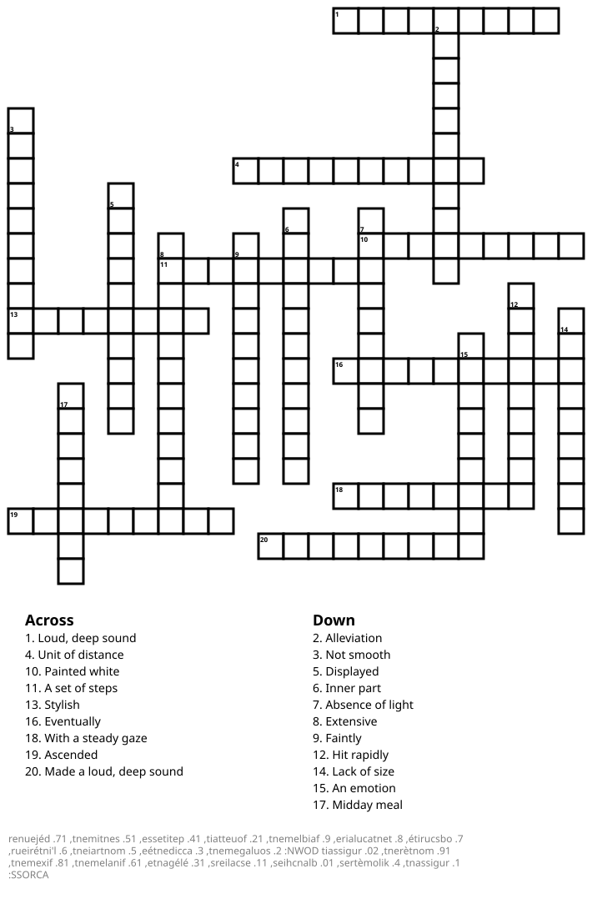

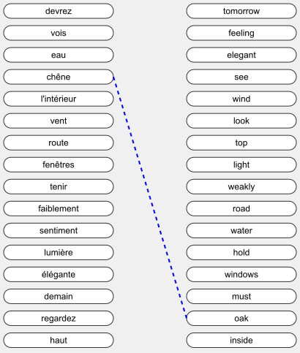

pot - tuah ,kool - zedrager ,worromot - niamed ,tnagele - etnagélé ,thgil - erèimul ,gnileef - tnemitnes ,ylkaew - tnemelbiaf ,dloh - rinet ,swodniw - sertênef ,daor - etuor ,dniw - tnev ,edisni - rueirétni'l ,kao - enêhc ,retaw - uae ,ees - siov ,tsum - zerved

# Chapter 1.4

Write down any words you need to memorise in the table below. Revisit the list regularly and use each column to tick off the words you have learned in that session. Use the visualisation LLM prompt at the start of the workbook and the 'method of loci' to help imprint the words in your memory. Try writing the words in sentences to help you remember them better.

|  |  |  |  |  |  |  |  |  |  |  |  |  |  |
| --- | --- | --- | --- | --- | --- | --- | --- | --- | --- | --- | --- | --- | --- |
| Word To Learn | ☑ | ☑ | ☑ | ☑ | ☑ | ☑ | ☑ | ☑ | ☑ | ☑ | ☑ | ☑ | ☑ |
|  |  |  |  |  |  |  |  |  |  |  |  |  |  |
|  |  |  |  |  |  |  |  |  |  |  |  |  |  |
|  |  |  |  |  |  |  |  |  |  |  |  |  |  |
|  |  |  |  |  |  |  |  |  |  |  |  |  |  |
|  |  |  |  |  |  |  |  |  |  |  |  |  |  |
|  |  |  |  |  |  |  |  |  |  |  |  |  |  |
|  |  |  |  |  |  |  |  |  |  |  |  |  |  |
|  |  |  |  |  |  |  |  |  |  |  |  |  |  |
|  |  |  |  |  |  |  |  |  |  |  |  |  |  |
|  |  |  |  |  |  |  |  |  |  |  |  |  |  |
|  |  |  |  |  |  |  |  |  |  |  |  |  |  |
|  |  |  |  |  |  |  |  |  |  |  |  |  |  |
|  |  |  |  |  |  |  |  |  |  |  |  |  |  |
|  |  |  |  |  |  |  |  |  |  |  |  |  |  |
|  |  |  |  |  |  |  |  |  |  |  |  |  |  |
|  |  |  |  |  |  |  |  |  |  |  |  |  |  |
|  |  |  |  |  |  |  |  |  |  |  |  |  |  |
|  |  |  |  |  |  |  |  |  |  |  |  |  |  |
|  |  |  |  |  |  |  |  |  |  |  |  |  |  |
|  |  |  |  |  |  |  |  |  |  |  |  |  |  |
|  |  |  |  |  |  |  |  |  |  |  |  |  |  |
|  |  |  |  |  |  |  |  |  |  |  |  |  |  |
|  |  |  |  |  |  |  |  |  |  |  |  |  |  |
|  |  |  |  |  |  |  |  |  |  |  |  |  |  |
|  |  |  |  |  |  |  |  |  |  |  |  |  |  |
|  |  |  |  |  |  |  |  |  |  |  |  |  |  |
|  |  |  |  |  |  |  |  |  |  |  |  |  |  |
|  |  |  |  |  |  |  |  |  |  |  |  |  |  |
|  |  |  |  |  |  |  |  |  |  |  |  |  |  |
|  |  |  |  |  |  |  |  |  |  |  |  |  |  |
|  |  |  |  |  |  |  |  |  |  |  |  |  |  |
|  |  |  |  |  |  |  |  |  |  |  |  |  |  |
|  |  |  |  |  |  |  |  |  |  |  |  |  |  |
|  |  |  |  |  |  |  |  |  |  |  |  |  |  |
|  |  |  |  |  |  |  |  |  |  |  |  |  |  |
|  |  |  |  |  |  |  |  |  |  |  |  |  |  |
|  |  |  |  |  |  |  |  |  |  |  |  |  |  |
|  |  |  |  |  |  |  |  |  |  |  |  |  |  |
|  |  |  |  |  |  |  |  |  |  |  |  |  |  |
|  |  |  |  |  |  |  |  |  |  |  |  |  |  |
|  |  |  |  |  |  |  |  |  |  |  |  |  |  |
|  |  |  |  |  |  |  |  |  |  |  |  |  |  |
|  |  |  |  |  |  |  |  |  |  |  |  |  |  |
|  |  |  |  |  |  |  |  |  |  |  |  |  |  |
|  |  |  |  |  |  |  |  |  |  |  |  |  |  |
|  |  |  |  |  |  |  |  |  |  |  |  |  |  |
|  |  |  |  |  |  |  |  |  |  |  |  |  |  |
|  |  |  |  |  |  |  |  |  |  |  |  |  |  |
|  |  |  |  |  |  |  |  |  |  |  |  |  |  |

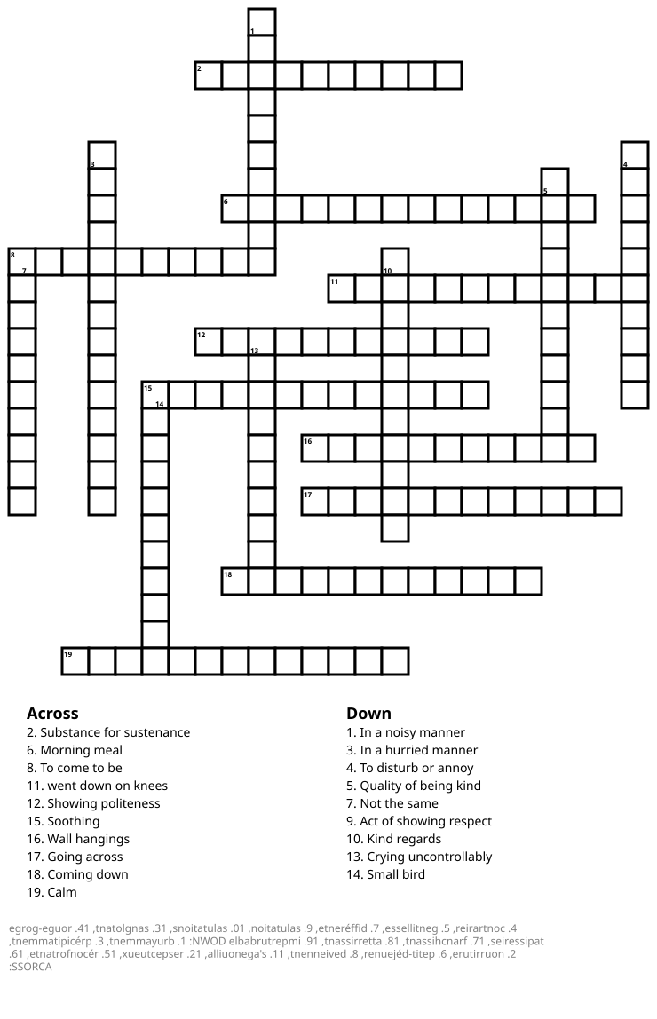

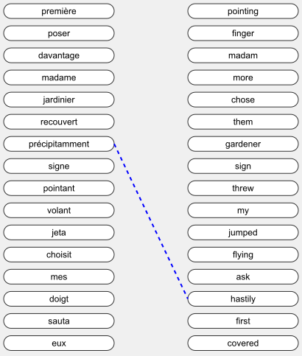

meht - xue ,depmuj - atuas ,regnif - tgiod ,ym - sem ,esohc - tisiohc ,werht - atej ,gniylf - tnalov ,gnitniop - tnatniop ,ngis - engis ,ylitsah - tnemmatipicérp ,derevoc - trevuocer ,renedrag - reinidraj ,madam - emadam ,erom - egatnavad ,ksa - resop ,tsrif - erèimerp

# Chapter 1.5

Write down any words you need to memorise in the table below. Revisit the list regularly and use each column to tick off the words you have learned in that session. Use the visualisation LLM prompt at the start of the workbook and the 'method of loci' to help imprint the words in your memory. Try writing the words in sentences to help you remember them better.

|  |  |  |  |  |  |  |  |  |  |  |  |  |  |
| --- | --- | --- | --- | --- | --- | --- | --- | --- | --- | --- | --- | --- | --- |
| Word To Learn | ☑ | ☑ | ☑ | ☑ | ☑ | ☑ | ☑ | ☑ | ☑ | ☑ | ☑ | ☑ | ☑ |
|  |  |  |  |  |  |  |  |  |  |  |  |  |  |
|  |  |  |  |  |  |  |  |  |  |  |  |  |  |
|  |  |  |  |  |  |  |  |  |  |  |  |  |  |
|  |  |  |  |  |  |  |  |  |  |  |  |  |  |
|  |  |  |  |  |  |  |  |  |  |  |  |  |  |
|  |  |  |  |  |  |  |  |  |  |  |  |  |  |
|  |  |  |  |  |  |  |  |  |  |  |  |  |  |
|  |  |  |  |  |  |  |  |  |  |  |  |  |  |
|  |  |  |  |  |  |  |  |  |  |  |  |  |  |
|  |  |  |  |  |  |  |  |  |  |  |  |  |  |
|  |  |  |  |  |  |  |  |  |  |  |  |  |  |
|  |  |  |  |  |  |  |  |  |  |  |  |  |  |
|  |  |  |  |  |  |  |  |  |  |  |  |  |  |
|  |  |  |  |  |  |  |  |  |  |  |  |  |  |
|  |  |  |  |  |  |  |  |  |  |  |  |  |  |
|  |  |  |  |  |  |  |  |  |  |  |  |  |  |
|  |  |  |  |  |  |  |  |  |  |  |  |  |  |
|  |  |  |  |  |  |  |  |  |  |  |  |  |  |
|  |  |  |  |  |  |  |  |  |  |  |  |  |  |
|  |  |  |  |  |  |  |  |  |  |  |  |  |  |
|  |  |  |  |  |  |  |  |  |  |  |  |  |  |
|  |  |  |  |  |  |  |  |  |  |  |  |  |  |
|  |  |  |  |  |  |  |  |  |  |  |  |  |  |
|  |  |  |  |  |  |  |  |  |  |  |  |  |  |
|  |  |  |  |  |  |  |  |  |  |  |  |  |  |
|  |  |  |  |  |  |  |  |  |  |  |  |  |  |
|  |  |  |  |  |  |  |  |  |  |  |  |  |  |
|  |  |  |  |  |  |  |  |  |  |  |  |  |  |
|  |  |  |  |  |  |  |  |  |  |  |  |  |  |
|  |  |  |  |  |  |  |  |  |  |  |  |  |  |
|  |  |  |  |  |  |  |  |  |  |  |  |  |  |
|  |  |  |  |  |  |  |  |  |  |  |  |  |  |
|  |  |  |  |  |  |  |  |  |  |  |  |  |  |
|  |  |  |  |  |  |  |  |  |  |  |  |  |  |
|  |  |  |  |  |  |  |  |  |  |  |  |  |  |
|  |  |  |  |  |  |  |  |  |  |  |  |  |  |
|  |  |  |  |  |  |  |  |  |  |  |  |  |  |
|  |  |  |  |  |  |  |  |  |  |  |  |  |  |
|  |  |  |  |  |  |  |  |  |  |  |  |  |  |
|  |  |  |  |  |  |  |  |  |  |  |  |  |  |
|  |  |  |  |  |  |  |  |  |  |  |  |  |  |
|  |  |  |  |  |  |  |  |  |  |  |  |  |  |
|  |  |  |  |  |  |  |  |  |  |  |  |  |  |
|  |  |  |  |  |  |  |  |  |  |  |  |  |  |
|  |  |  |  |  |  |  |  |  |  |  |  |  |  |
|  |  |  |  |  |  |  |  |  |  |  |  |  |  |
|  |  |  |  |  |  |  |  |  |  |  |  |  |  |
|  |  |  |  |  |  |  |  |  |  |  |  |  |  |
|  |  |  |  |  |  |  |  |  |  |  |  |  |  |

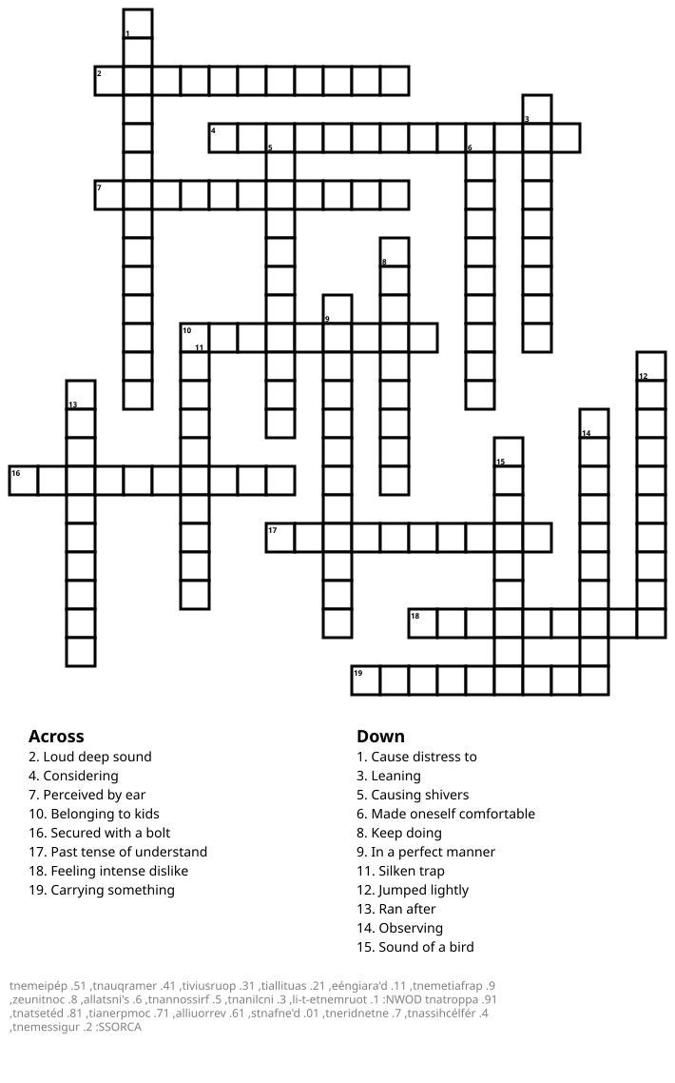

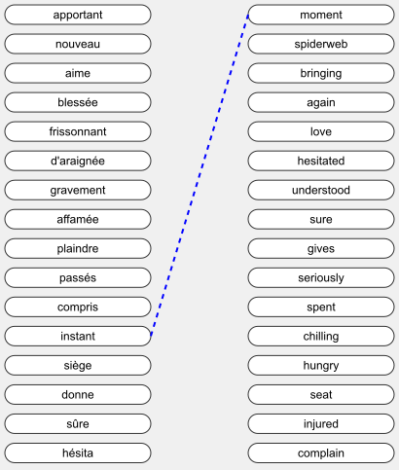

detatiseh - atiséh ,erus - erûs ,sevig - ennod ,taes - egèis ,tnemom - tnatsni ,dootsrednu - sirpmoc ,tneps - séssap ,nialpmoc - erdnialp ,yrgnuh - eémaffa ,ylsuoires - tnemevarg ,bewredips - eéngiara'd ,gnillihc - tnannossirf ,derujni - eésselb ,evol - emia ,niaga - uaevuon ,gnignirb - tnatroppa

# Chapter 1.6

Write down any words you need to memorise in the table below. Revisit the list regularly and use each column to tick off the words you have learned in that session. Use the visualisation LLM prompt at the start of the workbook and the 'method of loci' to help imprint the words in your memory. Try writing the words in sentences to help you remember them better.

|  |  |  |  |  |  |  |  |  |  |  |  |  |  |
| --- | --- | --- | --- | --- | --- | --- | --- | --- | --- | --- | --- | --- | --- |
| Word To Learn | ☑ | ☑ | ☑ | ☑ | ☑ | ☑ | ☑ | ☑ | ☑ | ☑ | ☑ | ☑ | ☑ |
|  |  |  |  |  |  |  |  |  |  |  |  |  |  |
|  |  |  |  |  |  |  |  |  |  |  |  |  |  |
|  |  |  |  |  |  |  |  |  |  |  |  |  |  |
|  |  |  |  |  |  |  |  |  |  |  |  |  |  |
|  |  |  |  |  |  |  |  |  |  |  |  |  |  |
|  |  |  |  |  |  |  |  |  |  |  |  |  |  |
|  |  |  |  |  |  |  |  |  |  |  |  |  |  |
|  |  |  |  |  |  |  |  |  |  |  |  |  |  |
|  |  |  |  |  |  |  |  |  |  |  |  |  |  |
|  |  |  |  |  |  |  |  |  |  |  |  |  |  |
|  |  |  |  |  |  |  |  |  |  |  |  |  |  |
|  |  |  |  |  |  |  |  |  |  |  |  |  |  |
|  |  |  |  |  |  |  |  |  |  |  |  |  |  |
|  |  |  |  |  |  |  |  |  |  |  |  |  |  |
|  |  |  |  |  |  |  |  |  |  |  |  |  |  |
|  |  |  |  |  |  |  |  |  |  |  |  |  |  |
|  |  |  |  |  |  |  |  |  |  |  |  |  |  |
|  |  |  |  |  |  |  |  |  |  |  |  |  |  |
|  |  |  |  |  |  |  |  |  |  |  |  |  |  |
|  |  |  |  |  |  |  |  |  |  |  |  |  |  |
|  |  |  |  |  |  |  |  |  |  |  |  |  |  |
|  |  |  |  |  |  |  |  |  |  |  |  |  |  |
|  |  |  |  |  |  |  |  |  |  |  |  |  |  |
|  |  |  |  |  |  |  |  |  |  |  |  |  |  |
|  |  |  |  |  |  |  |  |  |  |  |  |  |  |
|  |  |  |  |  |  |  |  |  |  |  |  |  |  |
|  |  |  |  |  |  |  |  |  |  |  |  |  |  |
|  |  |  |  |  |  |  |  |  |  |  |  |  |  |
|  |  |  |  |  |  |  |  |  |  |  |  |  |  |
|  |  |  |  |  |  |  |  |  |  |  |  |  |  |
|  |  |  |  |  |  |  |  |  |  |  |  |  |  |
|  |  |  |  |  |  |  |  |  |  |  |  |  |  |
|  |  |  |  |  |  |  |  |  |  |  |  |  |  |
|  |  |  |  |  |  |  |  |  |  |  |  |  |  |
|  |  |  |  |  |  |  |  |  |  |  |  |  |  |
|  |  |  |  |  |  |  |  |  |  |  |  |  |  |
|  |  |  |  |  |  |  |  |  |  |  |  |  |  |
|  |  |  |  |  |  |  |  |  |  |  |  |  |  |
|  |  |  |  |  |  |  |  |  |  |  |  |  |  |
|  |  |  |  |  |  |  |  |  |  |  |  |  |  |
|  |  |  |  |  |  |  |  |  |  |  |  |  |  |
|  |  |  |  |  |  |  |  |  |  |  |  |  |  |
|  |  |  |  |  |  |  |  |  |  |  |  |  |  |
|  |  |  |  |  |  |  |  |  |  |  |  |  |  |
|  |  |  |  |  |  |  |  |  |  |  |  |  |  |
|  |  |  |  |  |  |  |  |  |  |  |  |  |  |
|  |  |  |  |  |  |  |  |  |  |  |  |  |  |
|  |  |  |  |  |  |  |  |  |  |  |  |  |  |
|  |  |  |  |  |  |  |  |  |  |  |  |  |  |

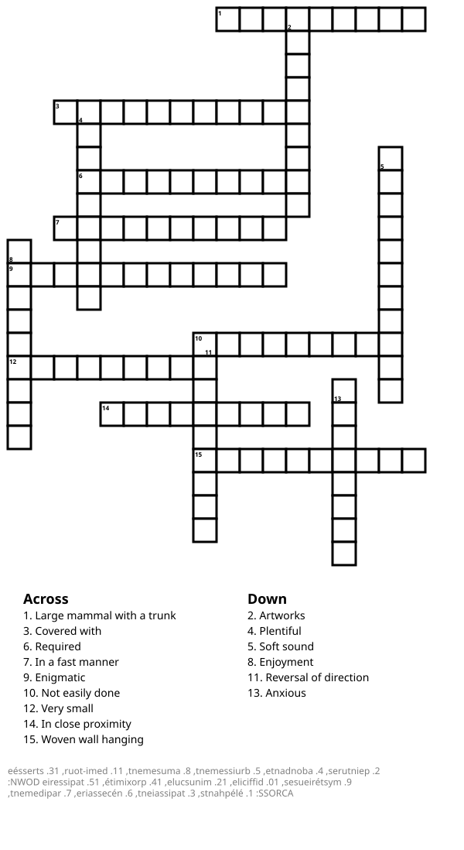

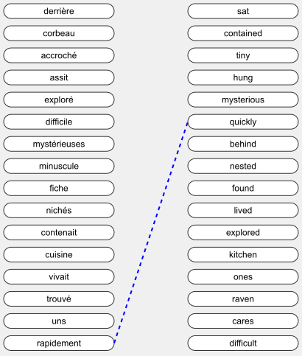

ylkciuq - tnemedipar ,seno - snu ,dnuof - évuort ,devil - tiaviv ,nehctik - enisiuc ,deniatnoc - tianetnoc ,detsen - séhcin ,serac - ehcif ,ynit - elucsunim ,suoiretsym - sesueirétsym ,tluciffid - eliciffid ,derolpxe - érolpxe ,tas - tissa ,gnuh - éhcorcca ,nevar - uaebroc ,dniheb - erèirred

# Chapter 1.7

Write down any words you need to memorise in the table below. Revisit the list regularly and use each column to tick off the words you have learned in that session. Use the visualisation LLM prompt at the start of the workbook and the 'method of loci' to help imprint the words in your memory. Try writing the words in sentences to help you remember them better.

|  |  |  |  |  |  |  |  |  |  |  |  |  |  |
| --- | --- | --- | --- | --- | --- | --- | --- | --- | --- | --- | --- | --- | --- |
| Word To Learn | ☑ | ☑ | ☑ | ☑ | ☑ | ☑ | ☑ | ☑ | ☑ | ☑ | ☑ | ☑ | ☑ |
|  |  |  |  |  |  |  |  |  |  |  |  |  |  |
|  |  |  |  |  |  |  |  |  |  |  |  |  |  |
|  |  |  |  |  |  |  |  |  |  |  |  |  |  |
|  |  |  |  |  |  |  |  |  |  |  |  |  |  |
|  |  |  |  |  |  |  |  |  |  |  |  |  |  |
|  |  |  |  |  |  |  |  |  |  |  |  |  |  |
|  |  |  |  |  |  |  |  |  |  |  |  |  |  |
|  |  |  |  |  |  |  |  |  |  |  |  |  |  |
|  |  |  |  |  |  |  |  |  |  |  |  |  |  |
|  |  |  |  |  |  |  |  |  |  |  |  |  |  |
|  |  |  |  |  |  |  |  |  |  |  |  |  |  |
|  |  |  |  |  |  |  |  |  |  |  |  |  |  |
|  |  |  |  |  |  |  |  |  |  |  |  |  |  |
|  |  |  |  |  |  |  |  |  |  |  |  |  |  |
|  |  |  |  |  |  |  |  |  |  |  |  |  |  |
|  |  |  |  |  |  |  |  |  |  |  |  |  |  |
|  |  |  |  |  |  |  |  |  |  |  |  |  |  |
|  |  |  |  |  |  |  |  |  |  |  |  |  |  |
|  |  |  |  |  |  |  |  |  |  |  |  |  |  |
|  |  |  |  |  |  |  |  |  |  |  |  |  |  |
|  |  |  |  |  |  |  |  |  |  |  |  |  |  |
|  |  |  |  |  |  |  |  |  |  |  |  |  |  |
|  |  |  |  |  |  |  |  |  |  |  |  |  |  |
|  |  |  |  |  |  |  |  |  |  |  |  |  |  |
|  |  |  |  |  |  |  |  |  |  |  |  |  |  |
|  |  |  |  |  |  |  |  |  |  |  |  |  |  |
|  |  |  |  |  |  |  |  |  |  |  |  |  |  |
|  |  |  |  |  |  |  |  |  |  |  |  |  |  |
|  |  |  |  |  |  |  |  |  |  |  |  |  |  |
|  |  |  |  |  |  |  |  |  |  |  |  |  |  |
|  |  |  |  |  |  |  |  |  |  |  |  |  |  |
|  |  |  |  |  |  |  |  |  |  |  |  |  |  |
|  |  |  |  |  |  |  |  |  |  |  |  |  |  |
|  |  |  |  |  |  |  |  |  |  |  |  |  |  |
|  |  |  |  |  |  |  |  |  |  |  |  |  |  |
|  |  |  |  |  |  |  |  |  |  |  |  |  |  |
|  |  |  |  |  |  |  |  |  |  |  |  |  |  |
|  |  |  |  |  |  |  |  |  |  |  |  |  |  |
|  |  |  |  |  |  |  |  |  |  |  |  |  |  |
|  |  |  |  |  |  |  |  |  |  |  |  |  |  |
|  |  |  |  |  |  |  |  |  |  |  |  |  |  |
|  |  |  |  |  |  |  |  |  |  |  |  |  |  |
|  |  |  |  |  |  |  |  |  |  |  |  |  |  |
|  |  |  |  |  |  |  |  |  |  |  |  |  |  |
|  |  |  |  |  |  |  |  |  |  |  |  |  |  |
|  |  |  |  |  |  |  |  |  |  |  |  |  |  |
|  |  |  |  |  |  |  |  |  |  |  |  |  |  |
|  |  |  |  |  |  |  |  |  |  |  |  |  |  |
|  |  |  |  |  |  |  |  |  |  |  |  |  |  |

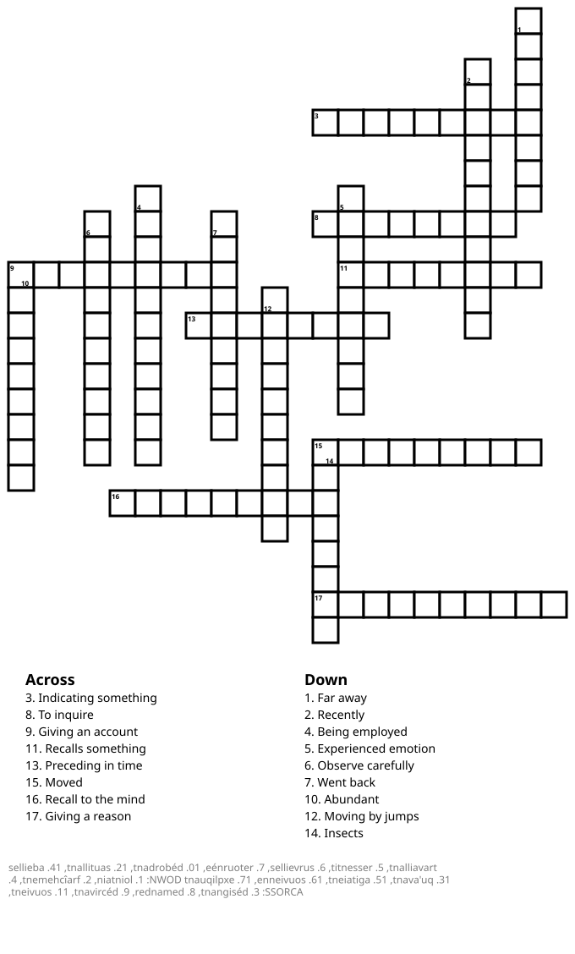

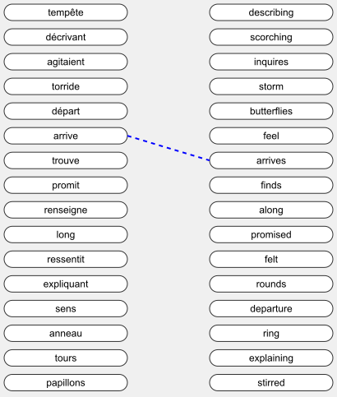

seilfrettub - snollipap ,sdnuor - sruot ,gnir - uaenna ,leef - snes ,gninialpxe - tnauqilpxe ,tlef - titnesser ,gnola - gnol ,seriuqni - engiesner ,desimorp - timorp ,sdnif - evuort ,sevirra - evirra ,erutraped - trapéd ,gnihcrocs - edirrot ,derrits - tneiatiga ,gnibircsed - tnavircéd ,mrots - etêpmet

# Chapter 1.8

Write down any words you need to memorise in the table below. Revisit the list regularly and use each column to tick off the words you have learned in that session. Use the visualisation LLM prompt at the start of the workbook and the 'method of loci' to help imprint the words in your memory. Try writing the words in sentences to help you remember them better.

|  |  |  |  |  |  |  |  |  |  |  |  |  |  |
| --- | --- | --- | --- | --- | --- | --- | --- | --- | --- | --- | --- | --- | --- |
| Word To Learn | ☑ | ☑ | ☑ | ☑ | ☑ | ☑ | ☑ | ☑ | ☑ | ☑ | ☑ | ☑ | ☑ |
|  |  |  |  |  |  |  |  |  |  |  |  |  |  |
|  |  |  |  |  |  |  |  |  |  |  |  |  |  |
|  |  |  |  |  |  |  |  |  |  |  |  |  |  |
|  |  |  |  |  |  |  |  |  |  |  |  |  |  |
|  |  |  |  |  |  |  |  |  |  |  |  |  |  |
|  |  |  |  |  |  |  |  |  |  |  |  |  |  |
|  |  |  |  |  |  |  |  |  |  |  |  |  |  |
|  |  |  |  |  |  |  |  |  |  |  |  |  |  |
|  |  |  |  |  |  |  |  |  |  |  |  |  |  |
|  |  |  |  |  |  |  |  |  |  |  |  |  |  |
|  |  |  |  |  |  |  |  |  |  |  |  |  |  |
|  |  |  |  |  |  |  |  |  |  |  |  |  |  |
|  |  |  |  |  |  |  |  |  |  |  |  |  |  |
|  |  |  |  |  |  |  |  |  |  |  |  |  |  |
|  |  |  |  |  |  |  |  |  |  |  |  |  |  |
|  |  |  |  |  |  |  |  |  |  |  |  |  |  |
|  |  |  |  |  |  |  |  |  |  |  |  |  |  |
|  |  |  |  |  |  |  |  |  |  |  |  |  |  |
|  |  |  |  |  |  |  |  |  |  |  |  |  |  |
|  |  |  |  |  |  |  |  |  |  |  |  |  |  |
|  |  |  |  |  |  |  |  |  |  |  |  |  |  |
|  |  |  |  |  |  |  |  |  |  |  |  |  |  |
|  |  |  |  |  |  |  |  |  |  |  |  |  |  |
|  |  |  |  |  |  |  |  |  |  |  |  |  |  |
|  |  |  |  |  |  |  |  |  |  |  |  |  |  |
|  |  |  |  |  |  |  |  |  |  |  |  |  |  |
|  |  |  |  |  |  |  |  |  |  |  |  |  |  |
|  |  |  |  |  |  |  |  |  |  |  |  |  |  |
|  |  |  |  |  |  |  |  |  |  |  |  |  |  |
|  |  |  |  |  |  |  |  |  |  |  |  |  |  |
|  |  |  |  |  |  |  |  |  |  |  |  |  |  |
|  |  |  |  |  |  |  |  |  |  |  |  |  |  |
|  |  |  |  |  |  |  |  |  |  |  |  |  |  |
|  |  |  |  |  |  |  |  |  |  |  |  |  |  |
|  |  |  |  |  |  |  |  |  |  |  |  |  |  |
|  |  |  |  |  |  |  |  |  |  |  |  |  |  |
|  |  |  |  |  |  |  |  |  |  |  |  |  |  |
|  |  |  |  |  |  |  |  |  |  |  |  |  |  |
|  |  |  |  |  |  |  |  |  |  |  |  |  |  |
|  |  |  |  |  |  |  |  |  |  |  |  |  |  |
|  |  |  |  |  |  |  |  |  |  |  |  |  |  |
|  |  |  |  |  |  |  |  |  |  |  |  |  |  |
|  |  |  |  |  |  |  |  |  |  |  |  |  |  |
|  |  |  |  |  |  |  |  |  |  |  |  |  |  |
|  |  |  |  |  |  |  |  |  |  |  |  |  |  |
|  |  |  |  |  |  |  |  |  |  |  |  |  |  |
|  |  |  |  |  |  |  |  |  |  |  |  |  |  |
|  |  |  |  |  |  |  |  |  |  |  |  |  |  |
|  |  |  |  |  |  |  |  |  |  |  |  |  |  |

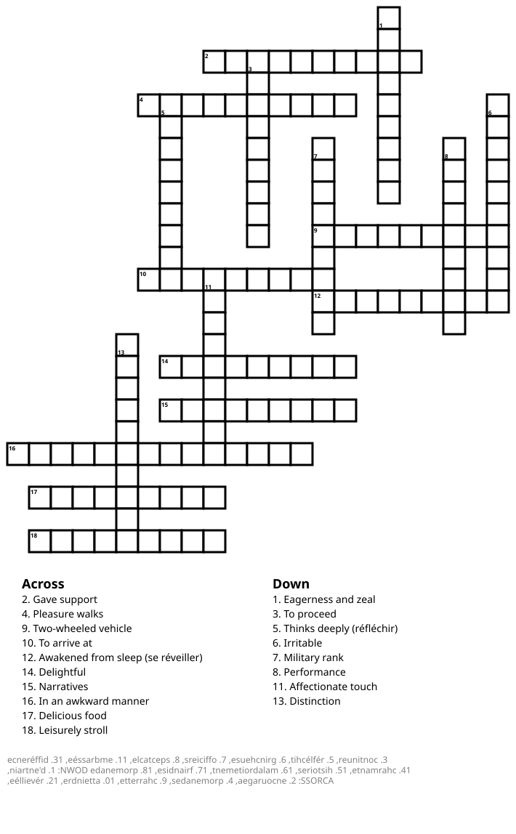

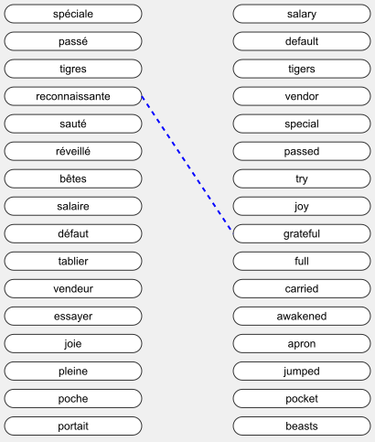

deirrac - tiatrop ,tekcop - ehcop ,lluf - enielp ,yoj - eioj ,yrt - reyasse ,rodnev - ruednev ,norpa - reilbat ,tluafed - tuaféd ,yralas - erialas ,stsaeb - setêb ,denekawa - éllievér ,depmuj - étuas ,lufetarg - etnassiannocer ,sregit - sergit ,dessap - éssap ,laiceps - elaicéps

# Chapter 1.9

Write down any words you need to memorise in the table below. Revisit the list regularly and use each column to tick off the words you have learned in that session. Use the visualisation LLM prompt at the start of the workbook and the 'method of loci' to help imprint the words in your memory. Try writing the words in sentences to help you remember them better.

|  |  |  |  |  |  |  |  |  |  |  |  |  |  |
| --- | --- | --- | --- | --- | --- | --- | --- | --- | --- | --- | --- | --- | --- |
| Word To Learn | ☑ | ☑ | ☑ | ☑ | ☑ | ☑ | ☑ | ☑ | ☑ | ☑ | ☑ | ☑ | ☑ |
|  |  |  |  |  |  |  |  |  |  |  |  |  |  |
|  |  |  |  |  |  |  |  |  |  |  |  |  |  |
|  |  |  |  |  |  |  |  |  |  |  |  |  |  |
|  |  |  |  |  |  |  |  |  |  |  |  |  |  |
|  |  |  |  |  |  |  |  |  |  |  |  |  |  |
|  |  |  |  |  |  |  |  |  |  |  |  |  |  |
|  |  |  |  |  |  |  |  |  |  |  |  |  |  |
|  |  |  |  |  |  |  |  |  |  |  |  |  |  |
|  |  |  |  |  |  |  |  |  |  |  |  |  |  |
|  |  |  |  |  |  |  |  |  |  |  |  |  |  |
|  |  |  |  |  |  |  |  |  |  |  |  |  |  |
|  |  |  |  |  |  |  |  |  |  |  |  |  |  |
|  |  |  |  |  |  |  |  |  |  |  |  |  |  |
|  |  |  |  |  |  |  |  |  |  |  |  |  |  |
|  |  |  |  |  |  |  |  |  |  |  |  |  |  |
|  |  |  |  |  |  |  |  |  |  |  |  |  |  |
|  |  |  |  |  |  |  |  |  |  |  |  |  |  |
|  |  |  |  |  |  |  |  |  |  |  |  |  |  |
|  |  |  |  |  |  |  |  |  |  |  |  |  |  |
|  |  |  |  |  |  |  |  |  |  |  |  |  |  |
|  |  |  |  |  |  |  |  |  |  |  |  |  |  |
|  |  |  |  |  |  |  |  |  |  |  |  |  |  |
|  |  |  |  |  |  |  |  |  |  |  |  |  |  |
|  |  |  |  |  |  |  |  |  |  |  |  |  |  |
|  |  |  |  |  |  |  |  |  |  |  |  |  |  |
|  |  |  |  |  |  |  |  |  |  |  |  |  |  |
|  |  |  |  |  |  |  |  |  |  |  |  |  |  |
|  |  |  |  |  |  |  |  |  |  |  |  |  |  |
|  |  |  |  |  |  |  |  |  |  |  |  |  |  |
|  |  |  |  |  |  |  |  |  |  |  |  |  |  |
|  |  |  |  |  |  |  |  |  |  |  |  |  |  |
|  |  |  |  |  |  |  |  |  |  |  |  |  |  |
|  |  |  |  |  |  |  |  |  |  |  |  |  |  |
|  |  |  |  |  |  |  |  |  |  |  |  |  |  |
|  |  |  |  |  |  |  |  |  |  |  |  |  |  |
|  |  |  |  |  |  |  |  |  |  |  |  |  |  |
|  |  |  |  |  |  |  |  |  |  |  |  |  |  |
|  |  |  |  |  |  |  |  |  |  |  |  |  |  |
|  |  |  |  |  |  |  |  |  |  |  |  |  |  |
|  |  |  |  |  |  |  |  |  |  |  |  |  |  |
|  |  |  |  |  |  |  |  |  |  |  |  |  |  |
|  |  |  |  |  |  |  |  |  |  |  |  |  |  |
|  |  |  |  |  |  |  |  |  |  |  |  |  |  |
|  |  |  |  |  |  |  |  |  |  |  |  |  |  |
|  |  |  |  |  |  |  |  |  |  |  |  |  |  |
|  |  |  |  |  |  |  |  |  |  |  |  |  |  |
|  |  |  |  |  |  |  |  |  |  |  |  |  |  |
|  |  |  |  |  |  |  |  |  |  |  |  |  |  |
|  |  |  |  |  |  |  |  |  |  |  |  |  |  |

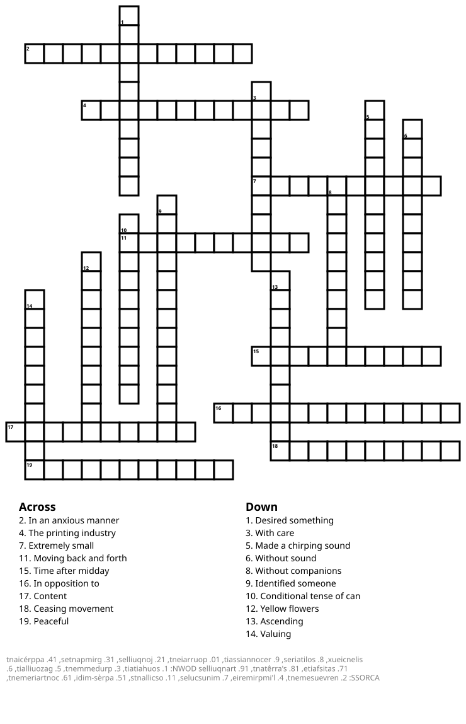

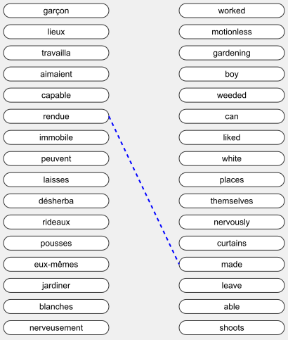

ylsuovren - tnemesuevren ,etihw - sehcnalb ,gninedrag - renidraj ,sevlesmeht - semêm-xue ,stoohs - sessuop ,sniatruc - xuaedir ,dedeew - abrehséd ,evael - sessial ,nac - tnevuep ,sselnoitom - elibommi ,edam - eudner ,elba - elbapac ,dekil - tneiamia ,dekrow - alliavart ,secalp - xueil ,yob - noçrag

# Chapter 1.10

Write down any words you need to memorise in the table below. Revisit the list regularly and use each column to tick off the words you have learned in that session. Use the visualisation LLM prompt at the start of the workbook and the 'method of loci' to help imprint the words in your memory. Try writing the words in sentences to help you remember them better.

|  |  |  |  |  |  |  |  |  |  |  |  |  |  |
| --- | --- | --- | --- | --- | --- | --- | --- | --- | --- | --- | --- | --- | --- |
| Word To Learn | ☑ | ☑ | ☑ | ☑ | ☑ | ☑ | ☑ | ☑ | ☑ | ☑ | ☑ | ☑ | ☑ |
|  |  |  |  |  |  |  |  |  |  |  |  |  |  |
|  |  |  |  |  |  |  |  |  |  |  |  |  |  |
|  |  |  |  |  |  |  |  |  |  |  |  |  |  |
|  |  |  |  |  |  |  |  |  |  |  |  |  |  |
|  |  |  |  |  |  |  |  |  |  |  |  |  |  |
|  |  |  |  |  |  |  |  |  |  |  |  |  |  |
|  |  |  |  |  |  |  |  |  |  |  |  |  |  |
|  |  |  |  |  |  |  |  |  |  |  |  |  |  |
|  |  |  |  |  |  |  |  |  |  |  |  |  |  |
|  |  |  |  |  |  |  |  |  |  |  |  |  |  |
|  |  |  |  |  |  |  |  |  |  |  |  |  |  |
|  |  |  |  |  |  |  |  |  |  |  |  |  |  |
|  |  |  |  |  |  |  |  |  |  |  |  |  |  |
|  |  |  |  |  |  |  |  |  |  |  |  |  |  |
|  |  |  |  |  |  |  |  |  |  |  |  |  |  |
|  |  |  |  |  |  |  |  |  |  |  |  |  |  |
|  |  |  |  |  |  |  |  |  |  |  |  |  |  |
|  |  |  |  |  |  |  |  |  |  |  |  |  |  |
|  |  |  |  |  |  |  |  |  |  |  |  |  |  |
|  |  |  |  |  |  |  |  |  |  |  |  |  |  |
|  |  |  |  |  |  |  |  |  |  |  |  |  |  |
|  |  |  |  |  |  |  |  |  |  |  |  |  |  |
|  |  |  |  |  |  |  |  |  |  |  |  |  |  |
|  |  |  |  |  |  |  |  |  |  |  |  |  |  |
|  |  |  |  |  |  |  |  |  |  |  |  |  |  |
|  |  |  |  |  |  |  |  |  |  |  |  |  |  |
|  |  |  |  |  |  |  |  |  |  |  |  |  |  |
|  |  |  |  |  |  |  |  |  |  |  |  |  |  |
|  |  |  |  |  |  |  |  |  |  |  |  |  |  |
|  |  |  |  |  |  |  |  |  |  |  |  |  |  |
|  |  |  |  |  |  |  |  |  |  |  |  |  |  |
|  |  |  |  |  |  |  |  |  |  |  |  |  |  |
|  |  |  |  |  |  |  |  |  |  |  |  |  |  |
|  |  |  |  |  |  |  |  |  |  |  |  |  |  |
|  |  |  |  |  |  |  |  |  |  |  |  |  |  |
|  |  |  |  |  |  |  |  |  |  |  |  |  |  |
|  |  |  |  |  |  |  |  |  |  |  |  |  |  |
|  |  |  |  |  |  |  |  |  |  |  |  |  |  |
|  |  |  |  |  |  |  |  |  |  |  |  |  |  |
|  |  |  |  |  |  |  |  |  |  |  |  |  |  |
|  |  |  |  |  |  |  |  |  |  |  |  |  |  |
|  |  |  |  |  |  |  |  |  |  |  |  |  |  |
|  |  |  |  |  |  |  |  |  |  |  |  |  |  |
|  |  |  |  |  |  |  |  |  |  |  |  |  |  |
|  |  |  |  |  |  |  |  |  |  |  |  |  |  |
|  |  |  |  |  |  |  |  |  |  |  |  |  |  |
|  |  |  |  |  |  |  |  |  |  |  |  |  |  |
|  |  |  |  |  |  |  |  |  |  |  |  |  |  |
|  |  |  |  |  |  |  |  |  |  |  |  |  |  |

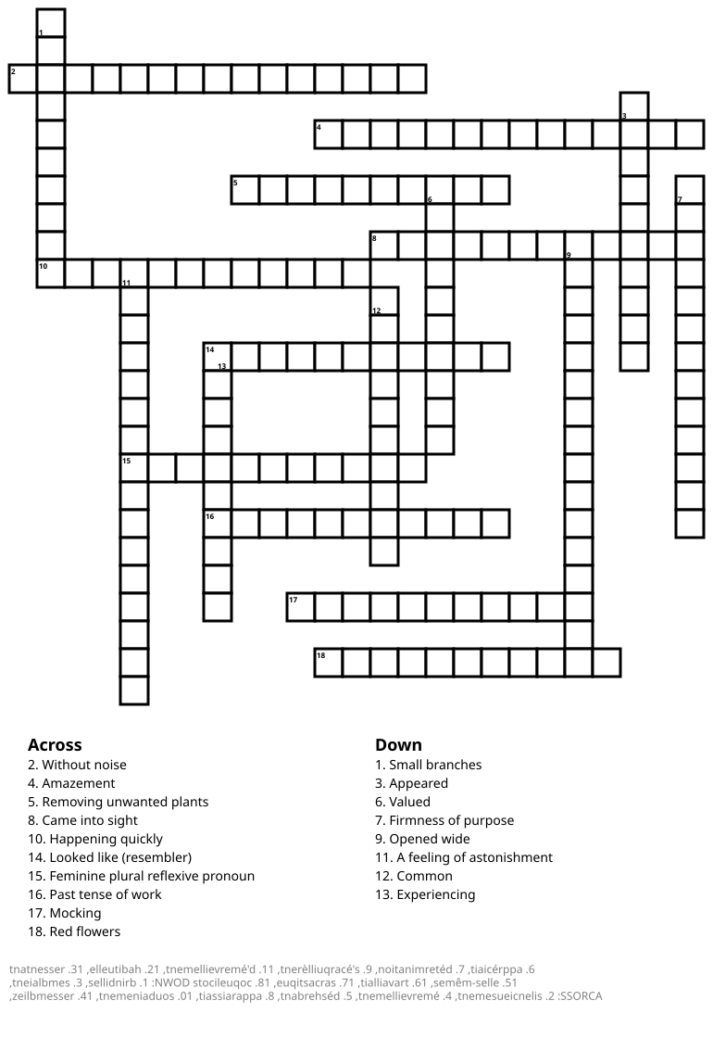

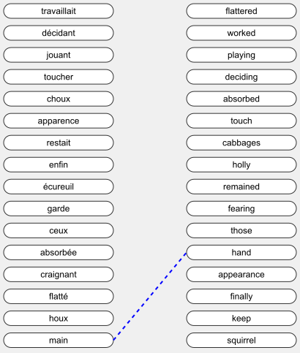

dnah - niam ,ylloh - xuoh ,derettalf - éttalf ,gniraef - tnangiarc ,debrosba - eébrosba ,esoht - xuec ,peek - edrag ,lerriuqs - liuerucé ,yllanif - nifne ,deniamer - tiatser ,ecnaraeppa - ecnerappa ,segabbac - xuohc ,hcuot - rehcuot ,gniyalp - tnauoj ,gnidiced - tnadicéd ,dekrow - tialliavart

# Chapter 1.11

Write down any words you need to memorise in the table below. Revisit the list regularly and use each column to tick off the words you have learned in that session. Use the visualisation LLM prompt at the start of the workbook and the 'method of loci' to help imprint the words in your memory. Try writing the words in sentences to help you remember them better.

|  |  |  |  |  |  |  |  |  |  |  |  |  |  |
| --- | --- | --- | --- | --- | --- | --- | --- | --- | --- | --- | --- | --- | --- |
| Word To Learn | ☑ | ☑ | ☑ | ☑ | ☑ | ☑ | ☑ | ☑ | ☑ | ☑ | ☑ | ☑ | ☑ |
|  |  |  |  |  |  |  |  |  |  |  |  |  |  |
|  |  |  |  |  |  |  |  |  |  |  |  |  |  |
|  |  |  |  |  |  |  |  |  |  |  |  |  |  |
|  |  |  |  |  |  |  |  |  |  |  |  |  |  |
|  |  |  |  |  |  |  |  |  |  |  |  |  |  |
|  |  |  |  |  |  |  |  |  |  |  |  |  |  |
|  |  |  |  |  |  |  |  |  |  |  |  |  |  |
|  |  |  |  |  |  |  |  |  |  |  |  |  |  |
|  |  |  |  |  |  |  |  |  |  |  |  |  |  |
|  |  |  |  |  |  |  |  |  |  |  |  |  |  |
|  |  |  |  |  |  |  |  |  |  |  |  |  |  |
|  |  |  |  |  |  |  |  |  |  |  |  |  |  |
|  |  |  |  |  |  |  |  |  |  |  |  |  |  |
|  |  |  |  |  |  |  |  |  |  |  |  |  |  |
|  |  |  |  |  |  |  |  |  |  |  |  |  |  |
|  |  |  |  |  |  |  |  |  |  |  |  |  |  |
|  |  |  |  |  |  |  |  |  |  |  |  |  |  |
|  |  |  |  |  |  |  |  |  |  |  |  |  |  |
|  |  |  |  |  |  |  |  |  |  |  |  |  |  |
|  |  |  |  |  |  |  |  |  |  |  |  |  |  |
|  |  |  |  |  |  |  |  |  |  |  |  |  |  |
|  |  |  |  |  |  |  |  |  |  |  |  |  |  |
|  |  |  |  |  |  |  |  |  |  |  |  |  |  |
|  |  |  |  |  |  |  |  |  |  |  |  |  |  |
|  |  |  |  |  |  |  |  |  |  |  |  |  |  |
|  |  |  |  |  |  |  |  |  |  |  |  |  |  |
|  |  |  |  |  |  |  |  |  |  |  |  |  |  |
|  |  |  |  |  |  |  |  |  |  |  |  |  |  |
|  |  |  |  |  |  |  |  |  |  |  |  |  |  |
|  |  |  |  |  |  |  |  |  |  |  |  |  |  |
|  |  |  |  |  |  |  |  |  |  |  |  |  |  |
|  |  |  |  |  |  |  |  |  |  |  |  |  |  |
|  |  |  |  |  |  |  |  |  |  |  |  |  |  |
|  |  |  |  |  |  |  |  |  |  |  |  |  |  |
|  |  |  |  |  |  |  |  |  |  |  |  |  |  |
|  |  |  |  |  |  |  |  |  |  |  |  |  |  |
|  |  |  |  |  |  |  |  |  |  |  |  |  |  |
|  |  |  |  |  |  |  |  |  |  |  |  |  |  |
|  |  |  |  |  |  |  |  |  |  |  |  |  |  |
|  |  |  |  |  |  |  |  |  |  |  |  |  |  |
|  |  |  |  |  |  |  |  |  |  |  |  |  |  |
|  |  |  |  |  |  |  |  |  |  |  |  |  |  |
|  |  |  |  |  |  |  |  |  |  |  |  |  |  |
|  |  |  |  |  |  |  |  |  |  |  |  |  |  |
|  |  |  |  |  |  |  |  |  |  |  |  |  |  |
|  |  |  |  |  |  |  |  |  |  |  |  |  |  |
|  |  |  |  |  |  |  |  |  |  |  |  |  |  |
|  |  |  |  |  |  |  |  |  |  |  |  |  |  |
|  |  |  |  |  |  |  |  |  |  |  |  |  |  |

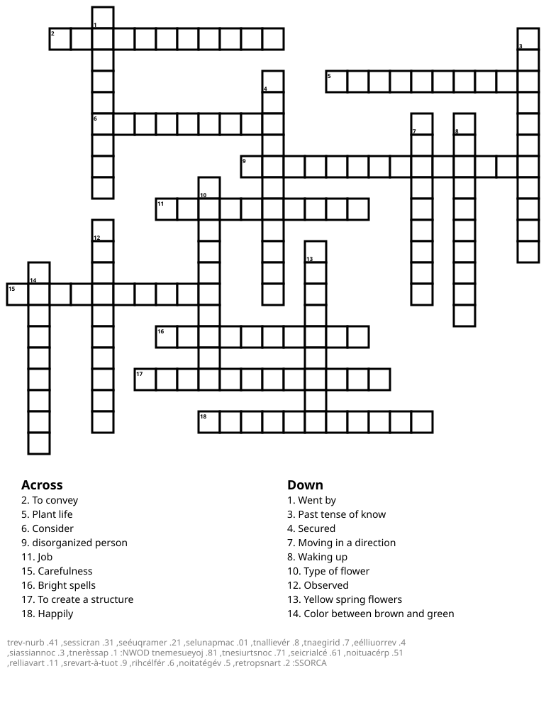

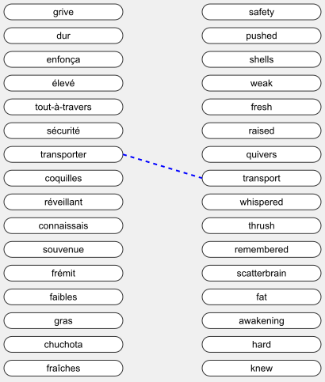

hserf - sehcîarf ,derepsihw - atohcuhc ,taf - sarg ,kaew - selbiaf ,sreviuq - timérf ,derebmemer - eunevuos ,wenk - siassiannoc ,gninekawa - tnallievér ,sllehs - selliuqoc ,tropsnart - retropsnart ,ytefas - étirucés ,niarbrettacs - srevart-à-tuot ,desiar - évelé ,dehsup - açnofne ,drah - rud ,hsurht - evirg

# Chapter 1.12

Write down any words you need to memorise in the table below. Revisit the list regularly and use each column to tick off the words you have learned in that session. Use the visualisation LLM prompt at the start of the workbook and the 'method of loci' to help imprint the words in your memory. Try writing the words in sentences to help you remember them better.

|  |  |  |  |  |  |  |  |  |  |  |  |  |  |
| --- | --- | --- | --- | --- | --- | --- | --- | --- | --- | --- | --- | --- | --- |
| Word To Learn | ☑ | ☑ | ☑ | ☑ | ☑ | ☑ | ☑ | ☑ | ☑ | ☑ | ☑ | ☑ | ☑ |
|  |  |  |  |  |  |  |  |  |  |  |  |  |  |
|  |  |  |  |  |  |  |  |  |  |  |  |  |  |
|  |  |  |  |  |  |  |  |  |  |  |  |  |  |
|  |  |  |  |  |  |  |  |  |  |  |  |  |  |
|  |  |  |  |  |  |  |  |  |  |  |  |  |  |
|  |  |  |  |  |  |  |  |  |  |  |  |  |  |
|  |  |  |  |  |  |  |  |  |  |  |  |  |  |
|  |  |  |  |  |  |  |  |  |  |  |  |  |  |
|  |  |  |  |  |  |  |  |  |  |  |  |  |  |
|  |  |  |  |  |  |  |  |  |  |  |  |  |  |
|  |  |  |  |  |  |  |  |  |  |  |  |  |  |
|  |  |  |  |  |  |  |  |  |  |  |  |  |  |
|  |  |  |  |  |  |  |  |  |  |  |  |  |  |
|  |  |  |  |  |  |  |  |  |  |  |  |  |  |
|  |  |  |  |  |  |  |  |  |  |  |  |  |  |
|  |  |  |  |  |  |  |  |  |  |  |  |  |  |
|  |  |  |  |  |  |  |  |  |  |  |  |  |  |
|  |  |  |  |  |  |  |  |  |  |  |  |  |  |
|  |  |  |  |  |  |  |  |  |  |  |  |  |  |
|  |  |  |  |  |  |  |  |  |  |  |  |  |  |
|  |  |  |  |  |  |  |  |  |  |  |  |  |  |
|  |  |  |  |  |  |  |  |  |  |  |  |  |  |
|  |  |  |  |  |  |  |  |  |  |  |  |  |  |
|  |  |  |  |  |  |  |  |  |  |  |  |  |  |
|  |  |  |  |  |  |  |  |  |  |  |  |  |  |
|  |  |  |  |  |  |  |  |  |  |  |  |  |  |
|  |  |  |  |  |  |  |  |  |  |  |  |  |  |
|  |  |  |  |  |  |  |  |  |  |  |  |  |  |
|  |  |  |  |  |  |  |  |  |  |  |  |  |  |
|  |  |  |  |  |  |  |  |  |  |  |  |  |  |
|  |  |  |  |  |  |  |  |  |  |  |  |  |  |
|  |  |  |  |  |  |  |  |  |  |  |  |  |  |
|  |  |  |  |  |  |  |  |  |  |  |  |  |  |
|  |  |  |  |  |  |  |  |  |  |  |  |  |  |
|  |  |  |  |  |  |  |  |  |  |  |  |  |  |
|  |  |  |  |  |  |  |  |  |  |  |  |  |  |
|  |  |  |  |  |  |  |  |  |  |  |  |  |  |
|  |  |  |  |  |  |  |  |  |  |  |  |  |  |
|  |  |  |  |  |  |  |  |  |  |  |  |  |  |
|  |  |  |  |  |  |  |  |  |  |  |  |  |  |
|  |  |  |  |  |  |  |  |  |  |  |  |  |  |
|  |  |  |  |  |  |  |  |  |  |  |  |  |  |
|  |  |  |  |  |  |  |  |  |  |  |  |  |  |
|  |  |  |  |  |  |  |  |  |  |  |  |  |  |
|  |  |  |  |  |  |  |  |  |  |  |  |  |  |
|  |  |  |  |  |  |  |  |  |  |  |  |  |  |
|  |  |  |  |  |  |  |  |  |  |  |  |  |  |
|  |  |  |  |  |  |  |  |  |  |  |  |  |  |
|  |  |  |  |  |  |  |  |  |  |  |  |  |  |

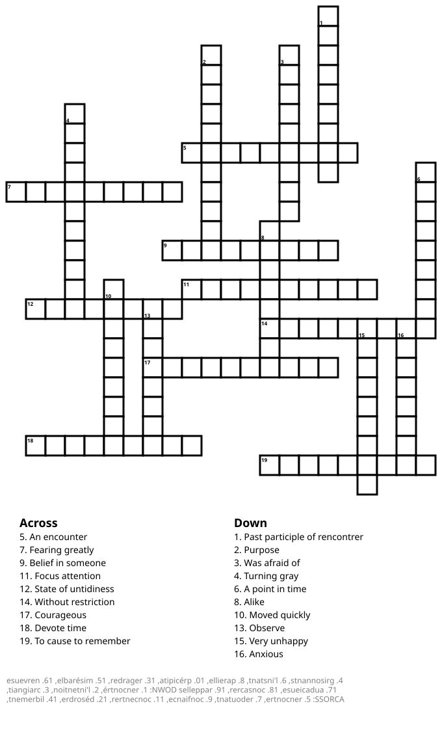

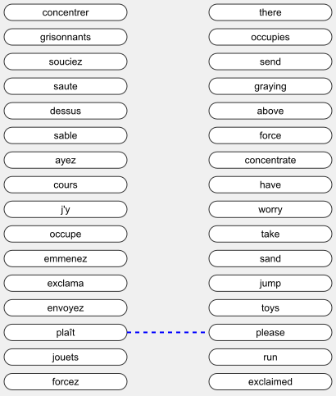

ecrof - zecrof ,syot - steuoj ,esaelp - tîalp ,dnes - zeyovne ,demialcxe - amalcxe ,ekat - zenemme ,seipucco - epucco ,ereht - y'j ,nur - sruoc ,evah - zeya ,dnas - elbas ,evoba - sussed ,pmuj - etuas ,yrrow - zeicuos ,gniyarg - stnannosirg ,etartnecnoc - rertnecnoc

# Chapter 1.13

Write down any words you need to memorise in the table below. Revisit the list regularly and use each column to tick off the words you have learned in that session. Use the visualisation LLM prompt at the start of the workbook and the 'method of loci' to help imprint the words in your memory. Try writing the words in sentences to help you remember them better.

|  |  |  |  |  |  |  |  |  |  |  |  |  |  |
| --- | --- | --- | --- | --- | --- | --- | --- | --- | --- | --- | --- | --- | --- |
| Word To Learn | ☑ | ☑ | ☑ | ☑ | ☑ | ☑ | ☑ | ☑ | ☑ | ☑ | ☑ | ☑ | ☑ |
|  |  |  |  |  |  |  |  |  |  |  |  |  |  |
|  |  |  |  |  |  |  |  |  |  |  |  |  |  |
|  |  |  |  |  |  |  |  |  |  |  |  |  |  |
|  |  |  |  |  |  |  |  |  |  |  |  |  |  |
|  |  |  |  |  |  |  |  |  |  |  |  |  |  |
|  |  |  |  |  |  |  |  |  |  |  |  |  |  |
|  |  |  |  |  |  |  |  |  |  |  |  |  |  |
|  |  |  |  |  |  |  |  |  |  |  |  |  |  |
|  |  |  |  |  |  |  |  |  |  |  |  |  |  |
|  |  |  |  |  |  |  |  |  |  |  |  |  |  |
|  |  |  |  |  |  |  |  |  |  |  |  |  |  |
|  |  |  |  |  |  |  |  |  |  |  |  |  |  |
|  |  |  |  |  |  |  |  |  |  |  |  |  |  |
|  |  |  |  |  |  |  |  |  |  |  |  |  |  |
|  |  |  |  |  |  |  |  |  |  |  |  |  |  |
|  |  |  |  |  |  |  |  |  |  |  |  |  |  |
|  |  |  |  |  |  |  |  |  |  |  |  |  |  |
|  |  |  |  |  |  |  |  |  |  |  |  |  |  |
|  |  |  |  |  |  |  |  |  |  |  |  |  |  |
|  |  |  |  |  |  |  |  |  |  |  |  |  |  |
|  |  |  |  |  |  |  |  |  |  |  |  |  |  |
|  |  |  |  |  |  |  |  |  |  |  |  |  |  |
|  |  |  |  |  |  |  |  |  |  |  |  |  |  |
|  |  |  |  |  |  |  |  |  |  |  |  |  |  |
|  |  |  |  |  |  |  |  |  |  |  |  |  |  |
|  |  |  |  |  |  |  |  |  |  |  |  |  |  |
|  |  |  |  |  |  |  |  |  |  |  |  |  |  |
|  |  |  |  |  |  |  |  |  |  |  |  |  |  |
|  |  |  |  |  |  |  |  |  |  |  |  |  |  |
|  |  |  |  |  |  |  |  |  |  |  |  |  |  |
|  |  |  |  |  |  |  |  |  |  |  |  |  |  |
|  |  |  |  |  |  |  |  |  |  |  |  |  |  |
|  |  |  |  |  |  |  |  |  |  |  |  |  |  |
|  |  |  |  |  |  |  |  |  |  |  |  |  |  |
|  |  |  |  |  |  |  |  |  |  |  |  |  |  |
|  |  |  |  |  |  |  |  |  |  |  |  |  |  |
|  |  |  |  |  |  |  |  |  |  |  |  |  |  |
|  |  |  |  |  |  |  |  |  |  |  |  |  |  |
|  |  |  |  |  |  |  |  |  |  |  |  |  |  |
|  |  |  |  |  |  |  |  |  |  |  |  |  |  |
|  |  |  |  |  |  |  |  |  |  |  |  |  |  |
|  |  |  |  |  |  |  |  |  |  |  |  |  |  |
|  |  |  |  |  |  |  |  |  |  |  |  |  |  |
|  |  |  |  |  |  |  |  |  |  |  |  |  |  |
|  |  |  |  |  |  |  |  |  |  |  |  |  |  |
|  |  |  |  |  |  |  |  |  |  |  |  |  |  |
|  |  |  |  |  |  |  |  |  |  |  |  |  |  |
|  |  |  |  |  |  |  |  |  |  |  |  |  |  |
|  |  |  |  |  |  |  |  |  |  |  |  |  |  |

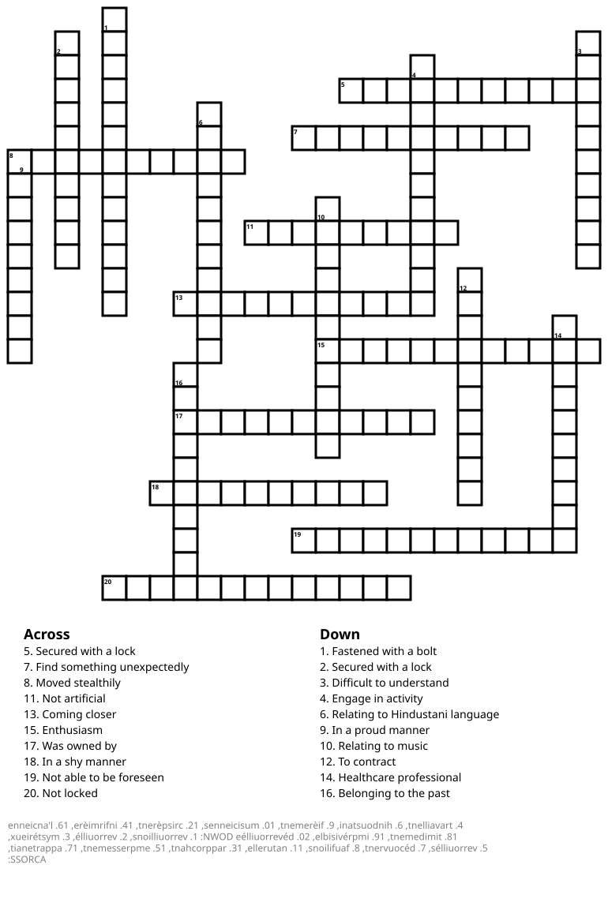

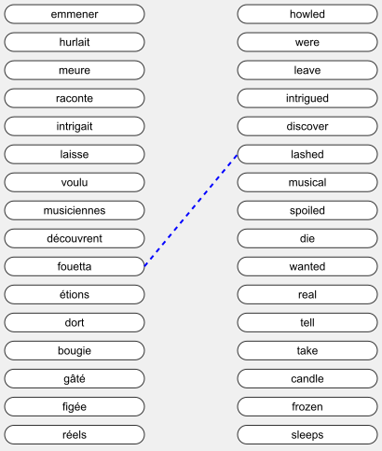

laer - sleér ,nezorf - eégif ,deliops - étâg ,eldnac - eiguob ,speels - trod ,erew - snoité ,dehsal - atteuof ,revocsid - tnervuocéd ,lacisum - senneicisum ,detnaw - uluov ,evael - essial ,deugirtni - tiagirtni ,llet - etnocar ,eid - eruem ,delwoh - tialruh ,ekat - renemme

# Chapter 1.14

Write down any words you need to memorise in the table below. Revisit the list regularly and use each column to tick off the words you have learned in that session. Use the visualisation LLM prompt at the start of the workbook and the 'method of loci' to help imprint the words in your memory. Try writing the words in sentences to help you remember them better.

|  |  |  |  |  |  |  |  |  |  |  |  |  |  |
| --- | --- | --- | --- | --- | --- | --- | --- | --- | --- | --- | --- | --- | --- |
| Word To Learn | ☑ | ☑ | ☑ | ☑ | ☑ | ☑ | ☑ | ☑ | ☑ | ☑ | ☑ | ☑ | ☑ |
|  |  |  |  |  |  |  |  |  |  |  |  |  |  |
|  |  |  |  |  |  |  |  |  |  |  |  |  |  |
|  |  |  |  |  |  |  |  |  |  |  |  |  |  |
|  |  |  |  |  |  |  |  |  |  |  |  |  |  |
|  |  |  |  |  |  |  |  |  |  |  |  |  |  |
|  |  |  |  |  |  |  |  |  |  |  |  |  |  |
|  |  |  |  |  |  |  |  |  |  |  |  |  |  |
|  |  |  |  |  |  |  |  |  |  |  |  |  |  |
|  |  |  |  |  |  |  |  |  |  |  |  |  |  |
|  |  |  |  |  |  |  |  |  |  |  |  |  |  |
|  |  |  |  |  |  |  |  |  |  |  |  |  |  |
|  |  |  |  |  |  |  |  |  |  |  |  |  |  |
|  |  |  |  |  |  |  |  |  |  |  |  |  |  |
|  |  |  |  |  |  |  |  |  |  |  |  |  |  |
|  |  |  |  |  |  |  |  |  |  |  |  |  |  |
|  |  |  |  |  |  |  |  |  |  |  |  |  |  |
|  |  |  |  |  |  |  |  |  |  |  |  |  |  |
|  |  |  |  |  |  |  |  |  |  |  |  |  |  |
|  |  |  |  |  |  |  |  |  |  |  |  |  |  |
|  |  |  |  |  |  |  |  |  |  |  |  |  |  |
|  |  |  |  |  |  |  |  |  |  |  |  |  |  |
|  |  |  |  |  |  |  |  |  |  |  |  |  |  |
|  |  |  |  |  |  |  |  |  |  |  |  |  |  |
|  |  |  |  |  |  |  |  |  |  |  |  |  |  |
|  |  |  |  |  |  |  |  |  |  |  |  |  |  |
|  |  |  |  |  |  |  |  |  |  |  |  |  |  |
|  |  |  |  |  |  |  |  |  |  |  |  |  |  |
|  |  |  |  |  |  |  |  |  |  |  |  |  |  |
|  |  |  |  |  |  |  |  |  |  |  |  |  |  |
|  |  |  |  |  |  |  |  |  |  |  |  |  |  |
|  |  |  |  |  |  |  |  |  |  |  |  |  |  |
|  |  |  |  |  |  |  |  |  |  |  |  |  |  |
|  |  |  |  |  |  |  |  |  |  |  |  |  |  |
|  |  |  |  |  |  |  |  |  |  |  |  |  |  |
|  |  |  |  |  |  |  |  |  |  |  |  |  |  |
|  |  |  |  |  |  |  |  |  |  |  |  |  |  |
|  |  |  |  |  |  |  |  |  |  |  |  |  |  |
|  |  |  |  |  |  |  |  |  |  |  |  |  |  |
|  |  |  |  |  |  |  |  |  |  |  |  |  |  |
|  |  |  |  |  |  |  |  |  |  |  |  |  |  |
|  |  |  |  |  |  |  |  |  |  |  |  |  |  |
|  |  |  |  |  |  |  |  |  |  |  |  |  |  |
|  |  |  |  |  |  |  |  |  |  |  |  |  |  |
|  |  |  |  |  |  |  |  |  |  |  |  |  |  |
|  |  |  |  |  |  |  |  |  |  |  |  |  |  |
|  |  |  |  |  |  |  |  |  |  |  |  |  |  |
|  |  |  |  |  |  |  |  |  |  |  |  |  |  |
|  |  |  |  |  |  |  |  |  |  |  |  |  |  |
|  |  |  |  |  |  |  |  |  |  |  |  |  |  |

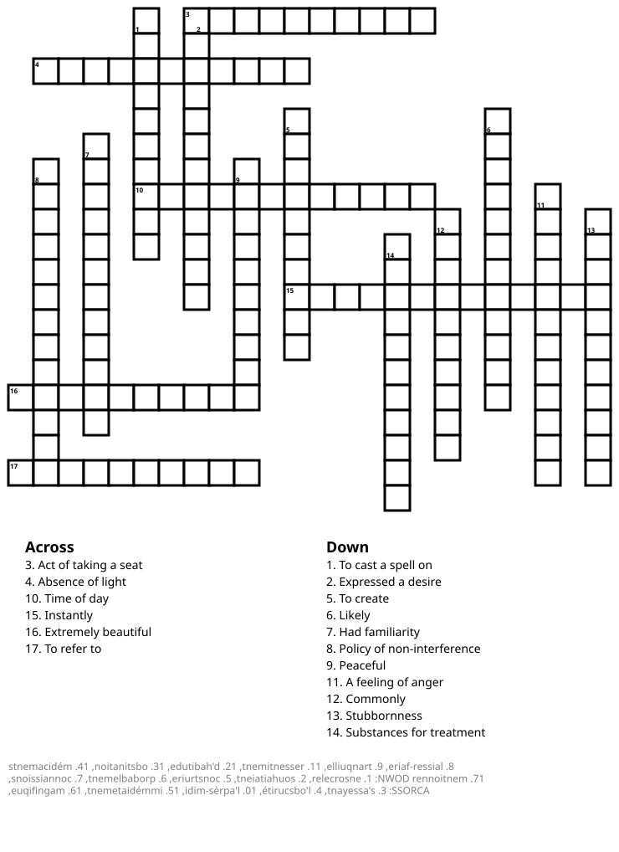

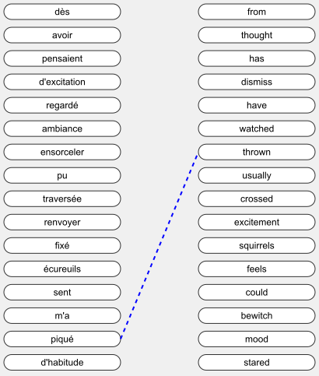

yllausu - edutibah'd ,nworht - éuqip ,sah - a'm ,sleef - tnes ,slerriuqs - sliuerucé ,derats - éxif ,ssimsid - reyovner ,dessorc - eésrevart ,dluoc - up ,hctiweb - relecrosne ,doom - ecnaibma ,dehctaw - édrager ,tnemeticxe - noitaticxe'd ,thguoht - tneiasnep ,evah - riova ,morf - sèd

# Chapter 1.15

Write down any words you need to memorise in the table below. Revisit the list regularly and use each column to tick off the words you have learned in that session. Use the visualisation LLM prompt at the start of the workbook and the 'method of loci' to help imprint the words in your memory. Try writing the words in sentences to help you remember them better.

|  |  |  |  |  |  |  |  |  |  |  |  |  |  |
| --- | --- | --- | --- | --- | --- | --- | --- | --- | --- | --- | --- | --- | --- |
| Word To Learn | ☑ | ☑ | ☑ | ☑ | ☑ | ☑ | ☑ | ☑ | ☑ | ☑ | ☑ | ☑ | ☑ |
|  |  |  |  |  |  |  |  |  |  |  |  |  |  |
|  |  |  |  |  |  |  |  |  |  |  |  |  |  |
|  |  |  |  |  |  |  |  |  |  |  |  |  |  |
|  |  |  |  |  |  |  |  |  |  |  |  |  |  |
|  |  |  |  |  |  |  |  |  |  |  |  |  |  |
|  |  |  |  |  |  |  |  |  |  |  |  |  |  |
|  |  |  |  |  |  |  |  |  |  |  |  |  |  |
|  |  |  |  |  |  |  |  |  |  |  |  |  |  |
|  |  |  |  |  |  |  |  |  |  |  |  |  |  |
|  |  |  |  |  |  |  |  |  |  |  |  |  |  |
|  |  |  |  |  |  |  |  |  |  |  |  |  |  |
|  |  |  |  |  |  |  |  |  |  |  |  |  |  |
|  |  |  |  |  |  |  |  |  |  |  |  |  |  |
|  |  |  |  |  |  |  |  |  |  |  |  |  |  |
|  |  |  |  |  |  |  |  |  |  |  |  |  |  |
|  |  |  |  |  |  |  |  |  |  |  |  |  |  |
|  |  |  |  |  |  |  |  |  |  |  |  |  |  |
|  |  |  |  |  |  |  |  |  |  |  |  |  |  |
|  |  |  |  |  |  |  |  |  |  |  |  |  |  |
|  |  |  |  |  |  |  |  |  |  |  |  |  |  |
|  |  |  |  |  |  |  |  |  |  |  |  |  |  |
|  |  |  |  |  |  |  |  |  |  |  |  |  |  |
|  |  |  |  |  |  |  |  |  |  |  |  |  |  |
|  |  |  |  |  |  |  |  |  |  |  |  |  |  |
|  |  |  |  |  |  |  |  |  |  |  |  |  |  |
|  |  |  |  |  |  |  |  |  |  |  |  |  |  |
|  |  |  |  |  |  |  |  |  |  |  |  |  |  |
|  |  |  |  |  |  |  |  |  |  |  |  |  |  |
|  |  |  |  |  |  |  |  |  |  |  |  |  |  |
|  |  |  |  |  |  |  |  |  |  |  |  |  |  |
|  |  |  |  |  |  |  |  |  |  |  |  |  |  |
|  |  |  |  |  |  |  |  |  |  |  |  |  |  |
|  |  |  |  |  |  |  |  |  |  |  |  |  |  |
|  |  |  |  |  |  |  |  |  |  |  |  |  |  |
|  |  |  |  |  |  |  |  |  |  |  |  |  |  |
|  |  |  |  |  |  |  |  |  |  |  |  |  |  |
|  |  |  |  |  |  |  |  |  |  |  |  |  |  |
|  |  |  |  |  |  |  |  |  |  |  |  |  |  |
|  |  |  |  |  |  |  |  |  |  |  |  |  |  |
|  |  |  |  |  |  |  |  |  |  |  |  |  |  |
|  |  |  |  |  |  |  |  |  |  |  |  |  |  |
|  |  |  |  |  |  |  |  |  |  |  |  |  |  |
|  |  |  |  |  |  |  |  |  |  |  |  |  |  |
|  |  |  |  |  |  |  |  |  |  |  |  |  |  |
|  |  |  |  |  |  |  |  |  |  |  |  |  |  |
|  |  |  |  |  |  |  |  |  |  |  |  |  |  |
|  |  |  |  |  |  |  |  |  |  |  |  |  |  |
|  |  |  |  |  |  |  |  |  |  |  |  |  |  |
|  |  |  |  |  |  |  |  |  |  |  |  |  |  |

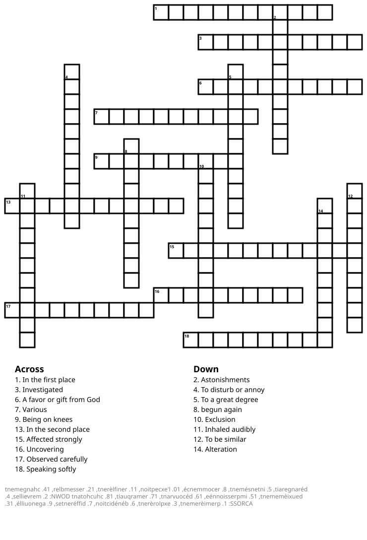

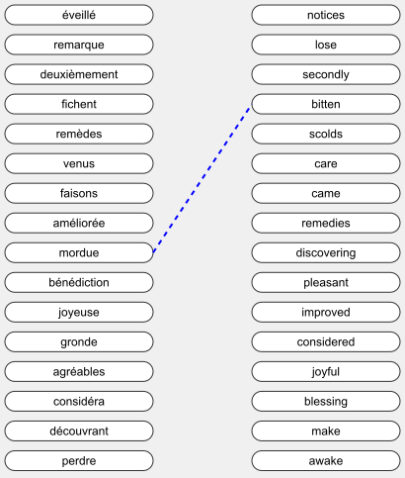

esol - erdrep ,gnirevocsid - tnarvuocéd ,deredisnoc - arédisnoc ,tnasaelp - selbaérga ,sdlocs - ednorg ,lufyoj - esueyoj ,gnisselb - noitcidénéb ,nettib - eudrom ,devorpmi - eéroiléma ,ekam - snosiaf ,emac - sunev ,seidemer - sedèmer ,erac - tnehcif ,yldnoces - tnememèixued ,seciton - euqramer ,ekawa - éllievé

# Chapter 1.16

Write down any words you need to memorise in the table below. Revisit the list regularly and use each column to tick off the words you have learned in that session. Use the visualisation LLM prompt at the start of the workbook and the 'method of loci' to help imprint the words in your memory. Try writing the words in sentences to help you remember them better.

|  |  |  |  |  |  |  |  |  |  |  |  |  |  |
| --- | --- | --- | --- | --- | --- | --- | --- | --- | --- | --- | --- | --- | --- |
| Word To Learn | ☑ | ☑ | ☑ | ☑ | ☑ | ☑ | ☑ | ☑ | ☑ | ☑ | ☑ | ☑ | ☑ |
|  |  |  |  |  |  |  |  |  |  |  |  |  |  |
|  |  |  |  |  |  |  |  |  |  |  |  |  |  |
|  |  |  |  |  |  |  |  |  |  |  |  |  |  |
|  |  |  |  |  |  |  |  |  |  |  |  |  |  |
|  |  |  |  |  |  |  |  |  |  |  |  |  |  |
|  |  |  |  |  |  |  |  |  |  |  |  |  |  |
|  |  |  |  |  |  |  |  |  |  |  |  |  |  |
|  |  |  |  |  |  |  |  |  |  |  |  |  |  |
|  |  |  |  |  |  |  |  |  |  |  |  |  |  |
|  |  |  |  |  |  |  |  |  |  |  |  |  |  |
|  |  |  |  |  |  |  |  |  |  |  |  |  |  |
|  |  |  |  |  |  |  |  |  |  |  |  |  |  |
|  |  |  |  |  |  |  |  |  |  |  |  |  |  |
|  |  |  |  |  |  |  |  |  |  |  |  |  |  |
|  |  |  |  |  |  |  |  |  |  |  |  |  |  |
|  |  |  |  |  |  |  |  |  |  |  |  |  |  |
|  |  |  |  |  |  |  |  |  |  |  |  |  |  |
|  |  |  |  |  |  |  |  |  |  |  |  |  |  |
|  |  |  |  |  |  |  |  |  |  |  |  |  |  |
|  |  |  |  |  |  |  |  |  |  |  |  |  |  |
|  |  |  |  |  |  |  |  |  |  |  |  |  |  |
|  |  |  |  |  |  |  |  |  |  |  |  |  |  |
|  |  |  |  |  |  |  |  |  |  |  |  |  |  |
|  |  |  |  |  |  |  |  |  |  |  |  |  |  |
|  |  |  |  |  |  |  |  |  |  |  |  |  |  |
|  |  |  |  |  |  |  |  |  |  |  |  |  |  |
|  |  |  |  |  |  |  |  |  |  |  |  |  |  |
|  |  |  |  |  |  |  |  |  |  |  |  |  |  |
|  |  |  |  |  |  |  |  |  |  |  |  |  |  |
|  |  |  |  |  |  |  |  |  |  |  |  |  |  |
|  |  |  |  |  |  |  |  |  |  |  |  |  |  |
|  |  |  |  |  |  |  |  |  |  |  |  |  |  |
|  |  |  |  |  |  |  |  |  |  |  |  |  |  |
|  |  |  |  |  |  |  |  |  |  |  |  |  |  |
|  |  |  |  |  |  |  |  |  |  |  |  |  |  |
|  |  |  |  |  |  |  |  |  |  |  |  |  |  |
|  |  |  |  |  |  |  |  |  |  |  |  |  |  |
|  |  |  |  |  |  |  |  |  |  |  |  |  |  |
|  |  |  |  |  |  |  |  |  |  |  |  |  |  |
|  |  |  |  |  |  |  |  |  |  |  |  |  |  |
|  |  |  |  |  |  |  |  |  |  |  |  |  |  |
|  |  |  |  |  |  |  |  |  |  |  |  |  |  |
|  |  |  |  |  |  |  |  |  |  |  |  |  |  |
|  |  |  |  |  |  |  |  |  |  |  |  |  |  |
|  |  |  |  |  |  |  |  |  |  |  |  |  |  |
|  |  |  |  |  |  |  |  |  |  |  |  |  |  |
|  |  |  |  |  |  |  |  |  |  |  |  |  |  |
|  |  |  |  |  |  |  |  |  |  |  |  |  |  |
|  |  |  |  |  |  |  |  |  |  |  |  |  |  |

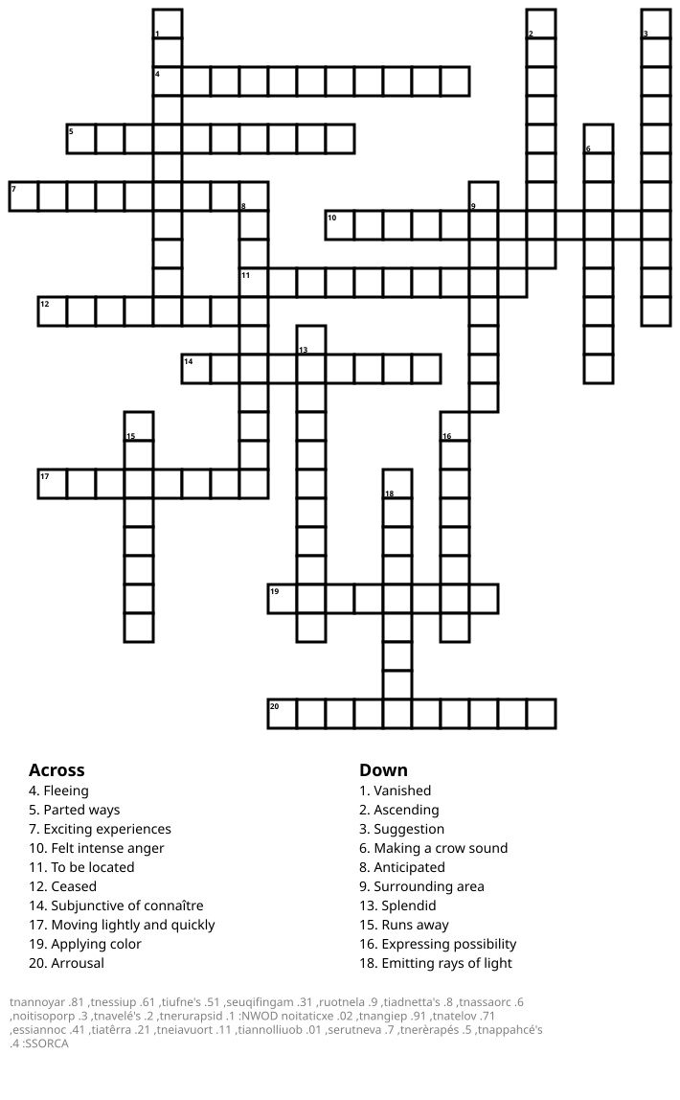

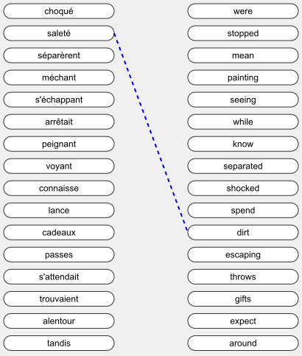

elihw - sidnat ,dnuora - ruotnela ,erew - tneiavuort ,tcepxe - tiadnetta's ,dneps - sessap ,stfig - xuaedac ,sworht - ecnal ,wonk - essiannoc ,gniees - tnayov ,gnitniap - tnangiep ,deppots - tiatêrra ,gnipacse - tnappahcé's ,naem - tnahcém ,detarapes - tnerèrapés ,trid - ételas ,dekcohs - éuqohc

# Chapter 1.17

Write down any words you need to memorise in the table below. Revisit the list regularly and use each column to tick off the words you have learned in that session. Use the visualisation LLM prompt at the start of the workbook and the 'method of loci' to help imprint the words in your memory. Try writing the words in sentences to help you remember them better.

|  |  |  |  |  |  |  |  |  |  |  |  |  |  |
| --- | --- | --- | --- | --- | --- | --- | --- | --- | --- | --- | --- | --- | --- |
| Word To Learn | ☑ | ☑ | ☑ | ☑ | ☑ | ☑ | ☑ | ☑ | ☑ | ☑ | ☑ | ☑ | ☑ |
|  |  |  |  |  |  |  |  |  |  |  |  |  |  |
|  |  |  |  |  |  |  |  |  |  |  |  |  |  |
|  |  |  |  |  |  |  |  |  |  |  |  |  |  |
|  |  |  |  |  |  |  |  |  |  |  |  |  |  |
|  |  |  |  |  |  |  |  |  |  |  |  |  |  |
|  |  |  |  |  |  |  |  |  |  |  |  |  |  |
|  |  |  |  |  |  |  |  |  |  |  |  |  |  |
|  |  |  |  |  |  |  |  |  |  |  |  |  |  |
|  |  |  |  |  |  |  |  |  |  |  |  |  |  |
|  |  |  |  |  |  |  |  |  |  |  |  |  |  |
|  |  |  |  |  |  |  |  |  |  |  |  |  |  |
|  |  |  |  |  |  |  |  |  |  |  |  |  |  |
|  |  |  |  |  |  |  |  |  |  |  |  |  |  |
|  |  |  |  |  |  |  |  |  |  |  |  |  |  |
|  |  |  |  |  |  |  |  |  |  |  |  |  |  |
|  |  |  |  |  |  |  |  |  |  |  |  |  |  |
|  |  |  |  |  |  |  |  |  |  |  |  |  |  |
|  |  |  |  |  |  |  |  |  |  |  |  |  |  |
|  |  |  |  |  |  |  |  |  |  |  |  |  |  |
|  |  |  |  |  |  |  |  |  |  |  |  |  |  |
|  |  |  |  |  |  |  |  |  |  |  |  |  |  |
|  |  |  |  |  |  |  |  |  |  |  |  |  |  |
|  |  |  |  |  |  |  |  |  |  |  |  |  |  |
|  |  |  |  |  |  |  |  |  |  |  |  |  |  |
|  |  |  |  |  |  |  |  |  |  |  |  |  |  |
|  |  |  |  |  |  |  |  |  |  |  |  |  |  |
|  |  |  |  |  |  |  |  |  |  |  |  |  |  |
|  |  |  |  |  |  |  |  |  |  |  |  |  |  |
|  |  |  |  |  |  |  |  |  |  |  |  |  |  |
|  |  |  |  |  |  |  |  |  |  |  |  |  |  |
|  |  |  |  |  |  |  |  |  |  |  |  |  |  |
|  |  |  |  |  |  |  |  |  |  |  |  |  |  |
|  |  |  |  |  |  |  |  |  |  |  |  |  |  |
|  |  |  |  |  |  |  |  |  |  |  |  |  |  |
|  |  |  |  |  |  |  |  |  |  |  |  |  |  |
|  |  |  |  |  |  |  |  |  |  |  |  |  |  |
|  |  |  |  |  |  |  |  |  |  |  |  |  |  |
|  |  |  |  |  |  |  |  |  |  |  |  |  |  |
|  |  |  |  |  |  |  |  |  |  |  |  |  |  |
|  |  |  |  |  |  |  |  |  |  |  |  |  |  |
|  |  |  |  |  |  |  |  |  |  |  |  |  |  |
|  |  |  |  |  |  |  |  |  |  |  |  |  |  |
|  |  |  |  |  |  |  |  |  |  |  |  |  |  |
|  |  |  |  |  |  |  |  |  |  |  |  |  |  |
|  |  |  |  |  |  |  |  |  |  |  |  |  |  |
|  |  |  |  |  |  |  |  |  |  |  |  |  |  |
|  |  |  |  |  |  |  |  |  |  |  |  |  |  |
|  |  |  |  |  |  |  |  |  |  |  |  |  |  |
|  |  |  |  |  |  |  |  |  |  |  |  |  |  |

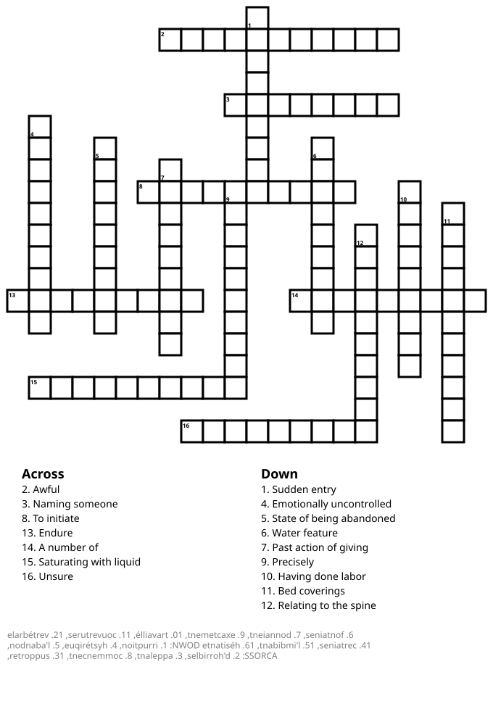

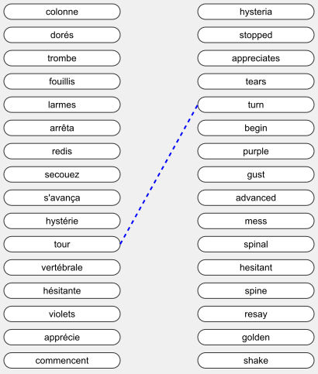

nigeb - tnecnemmoc ,setaicerppa - eicérppa ,elprup - steloiv ,tnatiseh - etnatiséh ,lanips - elarbétrev ,nrut - ruot ,airetsyh - eirétsyh ,decnavda - açnava's ,ekahs - zeuoces ,yaser - sider ,deppots - atêrra ,sraet - semral ,ssem - silliuof ,tsug - ebmort ,nedlog - sérod ,enips - ennoloc

# Chapter 1.18

Write down any words you need to memorise in the table below. Revisit the list regularly and use each column to tick off the words you have learned in that session. Use the visualisation LLM prompt at the start of the workbook and the 'method of loci' to help imprint the words in your memory. Try writing the words in sentences to help you remember them better.

|  |  |  |  |  |  |  |  |  |  |  |  |  |  |
| --- | --- | --- | --- | --- | --- | --- | --- | --- | --- | --- | --- | --- | --- |
| Word To Learn | ☑ | ☑ | ☑ | ☑ | ☑ | ☑ | ☑ | ☑ | ☑ | ☑ | ☑ | ☑ | ☑ |
|  |  |  |  |  |  |  |  |  |  |  |  |  |  |
|  |  |  |  |  |  |  |  |  |  |  |  |  |  |
|  |  |  |  |  |  |  |  |  |  |  |  |  |  |
|  |  |  |  |  |  |  |  |  |  |  |  |  |  |
|  |  |  |  |  |  |  |  |  |  |  |  |  |  |
|  |  |  |  |  |  |  |  |  |  |  |  |  |  |
|  |  |  |  |  |  |  |  |  |  |  |  |  |  |
|  |  |  |  |  |  |  |  |  |  |  |  |  |  |
|  |  |  |  |  |  |  |  |  |  |  |  |  |  |
|  |  |  |  |  |  |  |  |  |  |  |  |  |  |
|  |  |  |  |  |  |  |  |  |  |  |  |  |  |
|  |  |  |  |  |  |  |  |  |  |  |  |  |  |
|  |  |  |  |  |  |  |  |  |  |  |  |  |  |
|  |  |  |  |  |  |  |  |  |  |  |  |  |  |
|  |  |  |  |  |  |  |  |  |  |  |  |  |  |
|  |  |  |  |  |  |  |  |  |  |  |  |  |  |
|  |  |  |  |  |  |  |  |  |  |  |  |  |  |
|  |  |  |  |  |  |  |  |  |  |  |  |  |  |
|  |  |  |  |  |  |  |  |  |  |  |  |  |  |
|  |  |  |  |  |  |  |  |  |  |  |  |  |  |
|  |  |  |  |  |  |  |  |  |  |  |  |  |  |
|  |  |  |  |  |  |  |  |  |  |  |  |  |  |
|  |  |  |  |  |  |  |  |  |  |  |  |  |  |
|  |  |  |  |  |  |  |  |  |  |  |  |  |  |
|  |  |  |  |  |  |  |  |  |  |  |  |  |  |
|  |  |  |  |  |  |  |  |  |  |  |  |  |  |
|  |  |  |  |  |  |  |  |  |  |  |  |  |  |
|  |  |  |  |  |  |  |  |  |  |  |  |  |  |
|  |  |  |  |  |  |  |  |  |  |  |  |  |  |
|  |  |  |  |  |  |  |  |  |  |  |  |  |  |
|  |  |  |  |  |  |  |  |  |  |  |  |  |  |
|  |  |  |  |  |  |  |  |  |  |  |  |  |  |
|  |  |  |  |  |  |  |  |  |  |  |  |  |  |
|  |  |  |  |  |  |  |  |  |  |  |  |  |  |
|  |  |  |  |  |  |  |  |  |  |  |  |  |  |
|  |  |  |  |  |  |  |  |  |  |  |  |  |  |
|  |  |  |  |  |  |  |  |  |  |  |  |  |  |
|  |  |  |  |  |  |  |  |  |  |  |  |  |  |
|  |  |  |  |  |  |  |  |  |  |  |  |  |  |
|  |  |  |  |  |  |  |  |  |  |  |  |  |  |
|  |  |  |  |  |  |  |  |  |  |  |  |  |  |
|  |  |  |  |  |  |  |  |  |  |  |  |  |  |
|  |  |  |  |  |  |  |  |  |  |  |  |  |  |
|  |  |  |  |  |  |  |  |  |  |  |  |  |  |
|  |  |  |  |  |  |  |  |  |  |  |  |  |  |
|  |  |  |  |  |  |  |  |  |  |  |  |  |  |
|  |  |  |  |  |  |  |  |  |  |  |  |  |  |
|  |  |  |  |  |  |  |  |  |  |  |  |  |  |
|  |  |  |  |  |  |  |  |  |  |  |  |  |  |

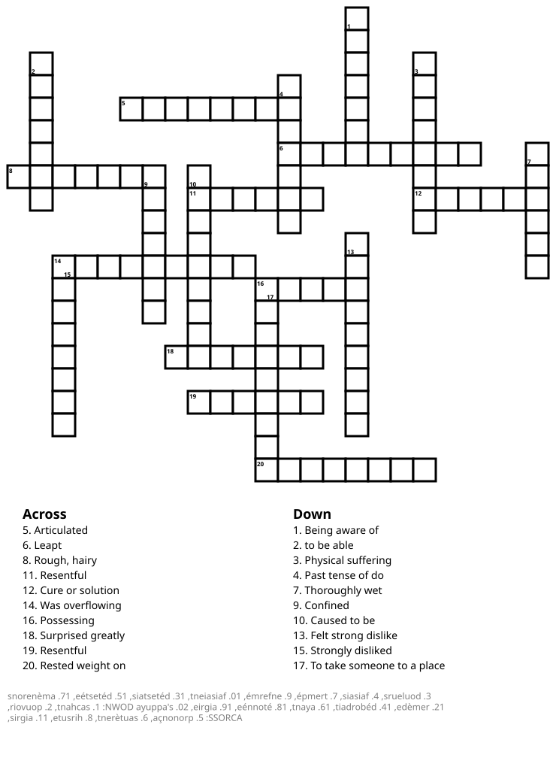

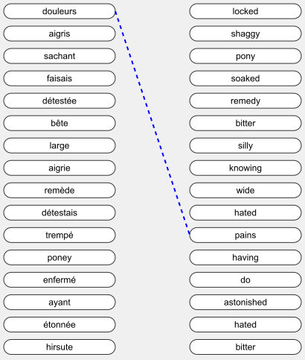

yggahs - etusrih ,dehsinotsa - eénnoté ,gnivah - tnaya ,dekcol - émrefne ,ynop - yenop ,dekaos - épmert ,detah - siatsetéd ,ydemer - edèmer ,rettib - eirgia ,ediw - egral ,yllis - etêb ,detah - eétsetéd ,od - siasiaf ,gniwonk - tnahcas ,rettib - sirgia ,sniap - srueluod

# Chapter 1.19

Write down any words you need to memorise in the table below. Revisit the list regularly and use each column to tick off the words you have learned in that session. Use the visualisation LLM prompt at the start of the workbook and the 'method of loci' to help imprint the words in your memory. Try writing the words in sentences to help you remember them better.

|  |  |  |  |  |  |  |  |  |  |  |  |  |  |
| --- | --- | --- | --- | --- | --- | --- | --- | --- | --- | --- | --- | --- | --- |
| Word To Learn | ☑ | ☑ | ☑ | ☑ | ☑ | ☑ | ☑ | ☑ | ☑ | ☑ | ☑ | ☑ | ☑ |
|  |  |  |  |  |  |  |  |  |  |  |  |  |  |
|  |  |  |  |  |  |  |  |  |  |  |  |  |  |
|  |  |  |  |  |  |  |  |  |  |  |  |  |  |
|  |  |  |  |  |  |  |  |  |  |  |  |  |  |
|  |  |  |  |  |  |  |  |  |  |  |  |  |  |
|  |  |  |  |  |  |  |  |  |  |  |  |  |  |
|  |  |  |  |  |  |  |  |  |  |  |  |  |  |
|  |  |  |  |  |  |  |  |  |  |  |  |  |  |
|  |  |  |  |  |  |  |  |  |  |  |  |  |  |
|  |  |  |  |  |  |  |  |  |  |  |  |  |  |
|  |  |  |  |  |  |  |  |  |  |  |  |  |  |
|  |  |  |  |  |  |  |  |  |  |  |  |  |  |
|  |  |  |  |  |  |  |  |  |  |  |  |  |  |
|  |  |  |  |  |  |  |  |  |  |  |  |  |  |
|  |  |  |  |  |  |  |  |  |  |  |  |  |  |
|  |  |  |  |  |  |  |  |  |  |  |  |  |  |
|  |  |  |  |  |  |  |  |  |  |  |  |  |  |
|  |  |  |  |  |  |  |  |  |  |  |  |  |  |
|  |  |  |  |  |  |  |  |  |  |  |  |  |  |
|  |  |  |  |  |  |  |  |  |  |  |  |  |  |
|  |  |  |  |  |  |  |  |  |  |  |  |  |  |
|  |  |  |  |  |  |  |  |  |  |  |  |  |  |
|  |  |  |  |  |  |  |  |  |  |  |  |  |  |
|  |  |  |  |  |  |  |  |  |  |  |  |  |  |
|  |  |  |  |  |  |  |  |  |  |  |  |  |  |
|  |  |  |  |  |  |  |  |  |  |  |  |  |  |
|  |  |  |  |  |  |  |  |  |  |  |  |  |  |
|  |  |  |  |  |  |  |  |  |  |  |  |  |  |
|  |  |  |  |  |  |  |  |  |  |  |  |  |  |
|  |  |  |  |  |  |  |  |  |  |  |  |  |  |
|  |  |  |  |  |  |  |  |  |  |  |  |  |  |
|  |  |  |  |  |  |  |  |  |  |  |  |  |  |
|  |  |  |  |  |  |  |  |  |  |  |  |  |  |
|  |  |  |  |  |  |  |  |  |  |  |  |  |  |
|  |  |  |  |  |  |  |  |  |  |  |  |  |  |
|  |  |  |  |  |  |  |  |  |  |  |  |  |  |
|  |  |  |  |  |  |  |  |  |  |  |  |  |  |
|  |  |  |  |  |  |  |  |  |  |  |  |  |  |
|  |  |  |  |  |  |  |  |  |  |  |  |  |  |
|  |  |  |  |  |  |  |  |  |  |  |  |  |  |
|  |  |  |  |  |  |  |  |  |  |  |  |  |  |
|  |  |  |  |  |  |  |  |  |  |  |  |  |  |
|  |  |  |  |  |  |  |  |  |  |  |  |  |  |
|  |  |  |  |  |  |  |  |  |  |  |  |  |  |
|  |  |  |  |  |  |  |  |  |  |  |  |  |  |
|  |  |  |  |  |  |  |  |  |  |  |  |  |  |
|  |  |  |  |  |  |  |  |  |  |  |  |  |  |
|  |  |  |  |  |  |  |  |  |  |  |  |  |  |
|  |  |  |  |  |  |  |  |  |  |  |  |  |  |

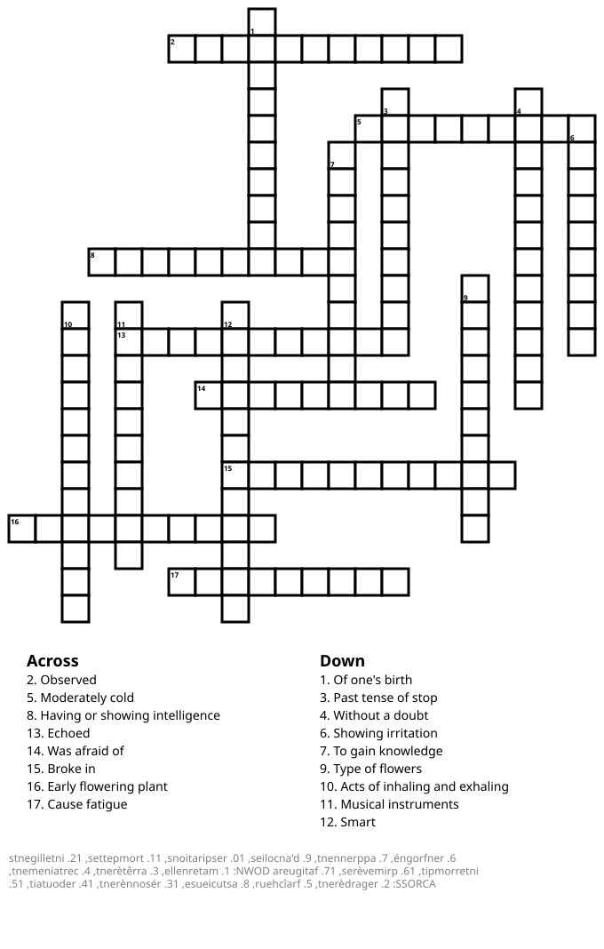

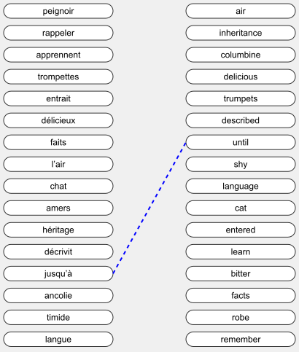

egaugnal - eugnal ,yhs - edimit ,enibmuloc - eilocna ,litnu - à’uqsuj ,debircsed - tivircéd ,ecnatirehni - egatiréh ,rettib - srema ,tac - tahc ,ria - ria’l ,stcaf - stiaf ,suoiciled - xueiciléd ,deretne - tiartne ,stepmurt - settepmort ,nrael - tnennerppa ,rebmemer - releppar ,ebor - riongiep

# Chapter 1.20

Write down any words you need to memorise in the table below. Revisit the list regularly and use each column to tick off the words you have learned in that session. Use the visualisation LLM prompt at the start of the workbook and the 'method of loci' to help imprint the words in your memory. Try writing the words in sentences to help you remember them better.

|  |  |  |  |  |  |  |  |  |  |  |  |  |  |
| --- | --- | --- | --- | --- | --- | --- | --- | --- | --- | --- | --- | --- | --- |
| Word To Learn | ☑ | ☑ | ☑ | ☑ | ☑ | ☑ | ☑ | ☑ | ☑ | ☑ | ☑ | ☑ | ☑ |
|  |  |  |  |  |  |  |  |  |  |  |  |  |  |
|  |  |  |  |  |  |  |  |  |  |  |  |  |  |
|  |  |  |  |  |  |  |  |  |  |  |  |  |  |
|  |  |  |  |  |  |  |  |  |  |  |  |  |  |
|  |  |  |  |  |  |  |  |  |  |  |  |  |  |
|  |  |  |  |  |  |  |  |  |  |  |  |  |  |
|  |  |  |  |  |  |  |  |  |  |  |  |  |  |
|  |  |  |  |  |  |  |  |  |  |  |  |  |  |
|  |  |  |  |  |  |  |  |  |  |  |  |  |  |
|  |  |  |  |  |  |  |  |  |  |  |  |  |  |
|  |  |  |  |  |  |  |  |  |  |  |  |  |  |
|  |  |  |  |  |  |  |  |  |  |  |  |  |  |
|  |  |  |  |  |  |  |  |  |  |  |  |  |  |
|  |  |  |  |  |  |  |  |  |  |  |  |  |  |
|  |  |  |  |  |  |  |  |  |  |  |  |  |  |
|  |  |  |  |  |  |  |  |  |  |  |  |  |  |
|  |  |  |  |  |  |  |  |  |  |  |  |  |  |
|  |  |  |  |  |  |  |  |  |  |  |  |  |  |
|  |  |  |  |  |  |  |  |  |  |  |  |  |  |
|  |  |  |  |  |  |  |  |  |  |  |  |  |  |
|  |  |  |  |  |  |  |  |  |  |  |  |  |  |
|  |  |  |  |  |  |  |  |  |  |  |  |  |  |
|  |  |  |  |  |  |  |  |  |  |  |  |  |  |
|  |  |  |  |  |  |  |  |  |  |  |  |  |  |
|  |  |  |  |  |  |  |  |  |  |  |  |  |  |
|  |  |  |  |  |  |  |  |  |  |  |  |  |  |
|  |  |  |  |  |  |  |  |  |  |  |  |  |  |
|  |  |  |  |  |  |  |  |  |  |  |  |  |  |
|  |  |  |  |  |  |  |  |  |  |  |  |  |  |
|  |  |  |  |  |  |  |  |  |  |  |  |  |  |
|  |  |  |  |  |  |  |  |  |  |  |  |  |  |
|  |  |  |  |  |  |  |  |  |  |  |  |  |  |
|  |  |  |  |  |  |  |  |  |  |  |  |  |  |
|  |  |  |  |  |  |  |  |  |  |  |  |  |  |
|  |  |  |  |  |  |  |  |  |  |  |  |  |  |
|  |  |  |  |  |  |  |  |  |  |  |  |  |  |
|  |  |  |  |  |  |  |  |  |  |  |  |  |  |
|  |  |  |  |  |  |  |  |  |  |  |  |  |  |
|  |  |  |  |  |  |  |  |  |  |  |  |  |  |
|  |  |  |  |  |  |  |  |  |  |  |  |  |  |
|  |  |  |  |  |  |  |  |  |  |  |  |  |  |
|  |  |  |  |  |  |  |  |  |  |  |  |  |  |
|  |  |  |  |  |  |  |  |  |  |  |  |  |  |
|  |  |  |  |  |  |  |  |  |  |  |  |  |  |
|  |  |  |  |  |  |  |  |  |  |  |  |  |  |
|  |  |  |  |  |  |  |  |  |  |  |  |  |  |
|  |  |  |  |  |  |  |  |  |  |  |  |  |  |
|  |  |  |  |  |  |  |  |  |  |  |  |  |  |
|  |  |  |  |  |  |  |  |  |  |  |  |  |  |

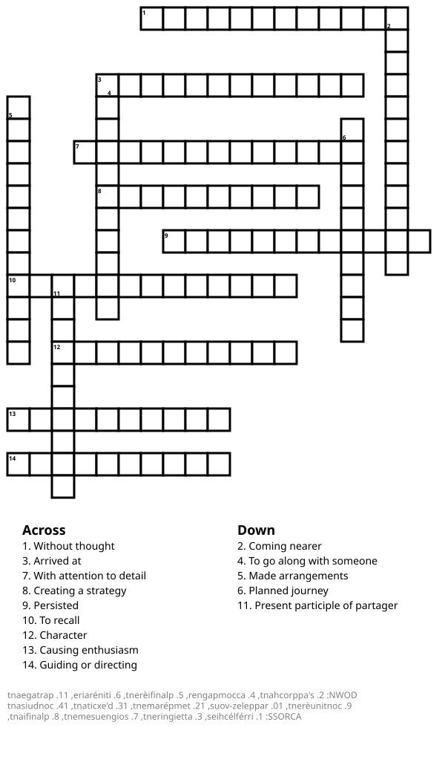

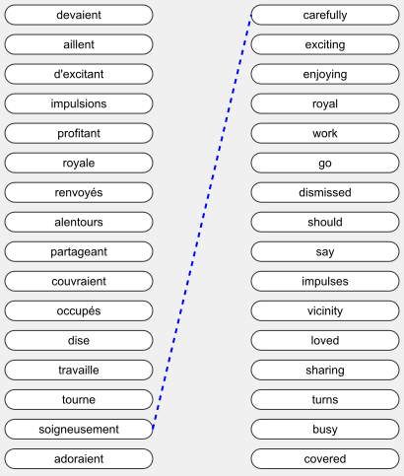

devol - tneiaroda ,ylluferac - tnemesuengios ,snrut - enruot ,krow - elliavart ,yas - esid ,ysub - sépucco ,derevoc - tneiarvuoc ,gnirahs - tnaegatrap ,ytiniciv - sruotnela ,dessimsid - séyovner ,layor - elayor ,gniyojne - tnatiforp ,seslupmi - snoislupmi ,gniticxe - tnaticxe'd ,og - tnellia ,dluohs - tneiaved

# Chapter 1.21

Write down any words you need to memorise in the table below. Revisit the list regularly and use each column to tick off the words you have learned in that session. Use the visualisation LLM prompt at the start of the workbook and the 'method of loci' to help imprint the words in your memory. Try writing the words in sentences to help you remember them better.

|  |  |  |  |  |  |  |  |  |  |  |  |  |  |
| --- | --- | --- | --- | --- | --- | --- | --- | --- | --- | --- | --- | --- | --- |
| Word To Learn | ☑ | ☑ | ☑ | ☑ | ☑ | ☑ | ☑ | ☑ | ☑ | ☑ | ☑ | ☑ | ☑ |
|  |  |  |  |  |  |  |  |  |  |  |  |  |  |
|  |  |  |  |  |  |  |  |  |  |  |  |  |  |
|  |  |  |  |  |  |  |  |  |  |  |  |  |  |
|  |  |  |  |  |  |  |  |  |  |  |  |  |  |
|  |  |  |  |  |  |  |  |  |  |  |  |  |  |
|  |  |  |  |  |  |  |  |  |  |  |  |  |  |
|  |  |  |  |  |  |  |  |  |  |  |  |  |  |
|  |  |  |  |  |  |  |  |  |  |  |  |  |  |
|  |  |  |  |  |  |  |  |  |  |  |  |  |  |
|  |  |  |  |  |  |  |  |  |  |  |  |  |  |
|  |  |  |  |  |  |  |  |  |  |  |  |  |  |
|  |  |  |  |  |  |  |  |  |  |  |  |  |  |
|  |  |  |  |  |  |  |  |  |  |  |  |  |  |
|  |  |  |  |  |  |  |  |  |  |  |  |  |  |
|  |  |  |  |  |  |  |  |  |  |  |  |  |  |
|  |  |  |  |  |  |  |  |  |  |  |  |  |  |
|  |  |  |  |  |  |  |  |  |  |  |  |  |  |
|  |  |  |  |  |  |  |  |  |  |  |  |  |  |
|  |  |  |  |  |  |  |  |  |  |  |  |  |  |
|  |  |  |  |  |  |  |  |  |  |  |  |  |  |
|  |  |  |  |  |  |  |  |  |  |  |  |  |  |
|  |  |  |  |  |  |  |  |  |  |  |  |  |  |
|  |  |  |  |  |  |  |  |  |  |  |  |  |  |
|  |  |  |  |  |  |  |  |  |  |  |  |  |  |
|  |  |  |  |  |  |  |  |  |  |  |  |  |  |
|  |  |  |  |  |  |  |  |  |  |  |  |  |  |
|  |  |  |  |  |  |  |  |  |  |  |  |  |  |
|  |  |  |  |  |  |  |  |  |  |  |  |  |  |
|  |  |  |  |  |  |  |  |  |  |  |  |  |  |
|  |  |  |  |  |  |  |  |  |  |  |  |  |  |
|  |  |  |  |  |  |  |  |  |  |  |  |  |  |
|  |  |  |  |  |  |  |  |  |  |  |  |  |  |
|  |  |  |  |  |  |  |  |  |  |  |  |  |  |
|  |  |  |  |  |  |  |  |  |  |  |  |  |  |
|  |  |  |  |  |  |  |  |  |  |  |  |  |  |
|  |  |  |  |  |  |  |  |  |  |  |  |  |  |
|  |  |  |  |  |  |  |  |  |  |  |  |  |  |
|  |  |  |  |  |  |  |  |  |  |  |  |  |  |
|  |  |  |  |  |  |  |  |  |  |  |  |  |  |
|  |  |  |  |  |  |  |  |  |  |  |  |  |  |
|  |  |  |  |  |  |  |  |  |  |  |  |  |  |
|  |  |  |  |  |  |  |  |  |  |  |  |  |  |
|  |  |  |  |  |  |  |  |  |  |  |  |  |  |
|  |  |  |  |  |  |  |  |  |  |  |  |  |  |
|  |  |  |  |  |  |  |  |  |  |  |  |  |  |
|  |  |  |  |  |  |  |  |  |  |  |  |  |  |
|  |  |  |  |  |  |  |  |  |  |  |  |  |  |
|  |  |  |  |  |  |  |  |  |  |  |  |  |  |
|  |  |  |  |  |  |  |  |  |  |  |  |  |  |

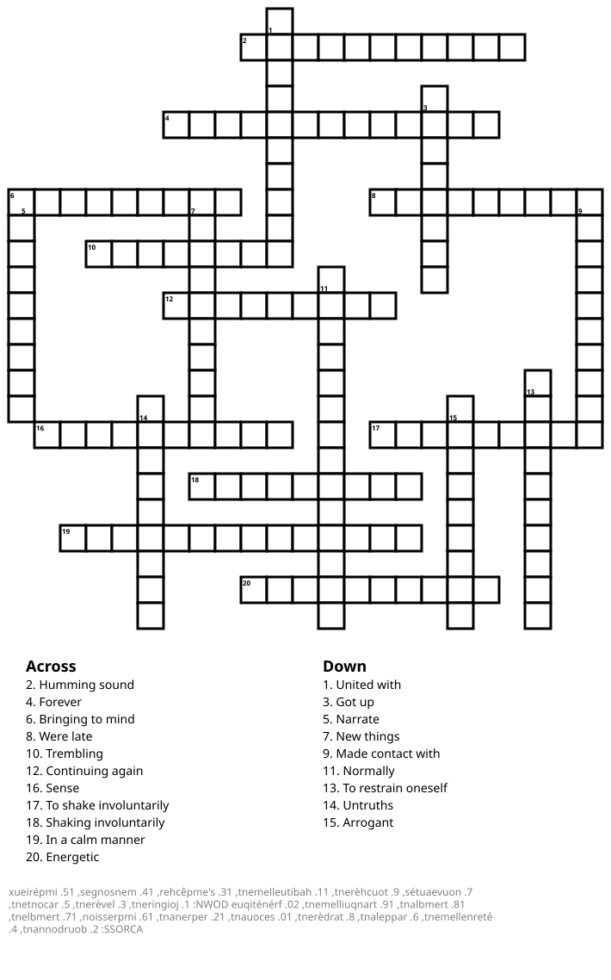

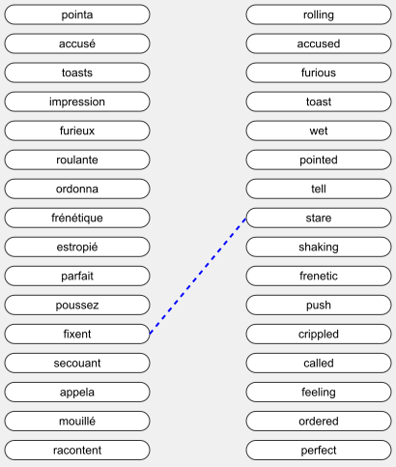

llet - tnetnocar ,tew - élliuom ,dellac - aleppa ,gnikahs - tnauoces ,erats - tnexif ,hsup - zessuop ,tcefrep - tiafrap ,delppirc - éiportse ,citenerf - euqiténérf ,deredro - annodro ,gnillor - etnaluor ,suoiruf - xueiruf ,gnileef - noisserpmi ,tsaot - stsaot ,desucca - ésucca ,detniop - atniop

# Chapter 1.22

Write down any words you need to memorise in the table below. Revisit the list regularly and use each column to tick off the words you have learned in that session. Use the visualisation LLM prompt at the start of the workbook and the 'method of loci' to help imprint the words in your memory. Try writing the words in sentences to help you remember them better.

|  |  |  |  |  |  |  |  |  |  |  |  |  |  |
| --- | --- | --- | --- | --- | --- | --- | --- | --- | --- | --- | --- | --- | --- |
| Word To Learn | ☑ | ☑ | ☑ | ☑ | ☑ | ☑ | ☑ | ☑ | ☑ | ☑ | ☑ | ☑ | ☑ |
|  |  |  |  |  |  |  |  |  |  |  |  |  |  |
|  |  |  |  |  |  |  |  |  |  |  |  |  |  |
|  |  |  |  |  |  |  |  |  |  |  |  |  |  |
|  |  |  |  |  |  |  |  |  |  |  |  |  |  |
|  |  |  |  |  |  |  |  |  |  |  |  |  |  |
|  |  |  |  |  |  |  |  |  |  |  |  |  |  |
|  |  |  |  |  |  |  |  |  |  |  |  |  |  |
|  |  |  |  |  |  |  |  |  |  |  |  |  |  |
|  |  |  |  |  |  |  |  |  |  |  |  |  |  |
|  |  |  |  |  |  |  |  |  |  |  |  |  |  |
|  |  |  |  |  |  |  |  |  |  |  |  |  |  |
|  |  |  |  |  |  |  |  |  |  |  |  |  |  |
|  |  |  |  |  |  |  |  |  |  |  |  |  |  |
|  |  |  |  |  |  |  |  |  |  |  |  |  |  |
|  |  |  |  |  |  |  |  |  |  |  |  |  |  |
|  |  |  |  |  |  |  |  |  |  |  |  |  |  |
|  |  |  |  |  |  |  |  |  |  |  |  |  |  |
|  |  |  |  |  |  |  |  |  |  |  |  |  |  |
|  |  |  |  |  |  |  |  |  |  |  |  |  |  |
|  |  |  |  |  |  |  |  |  |  |  |  |  |  |
|  |  |  |  |  |  |  |  |  |  |  |  |  |  |
|  |  |  |  |  |  |  |  |  |  |  |  |  |  |
|  |  |  |  |  |  |  |  |  |  |  |  |  |  |
|  |  |  |  |  |  |  |  |  |  |  |  |  |  |
|  |  |  |  |  |  |  |  |  |  |  |  |  |  |
|  |  |  |  |  |  |  |  |  |  |  |  |  |  |
|  |  |  |  |  |  |  |  |  |  |  |  |  |  |
|  |  |  |  |  |  |  |  |  |  |  |  |  |  |
|  |  |  |  |  |  |  |  |  |  |  |  |  |  |
|  |  |  |  |  |  |  |  |  |  |  |  |  |  |
|  |  |  |  |  |  |  |  |  |  |  |  |  |  |
|  |  |  |  |  |  |  |  |  |  |  |  |  |  |
|  |  |  |  |  |  |  |  |  |  |  |  |  |  |
|  |  |  |  |  |  |  |  |  |  |  |  |  |  |
|  |  |  |  |  |  |  |  |  |  |  |  |  |  |
|  |  |  |  |  |  |  |  |  |  |  |  |  |  |
|  |  |  |  |  |  |  |  |  |  |  |  |  |  |
|  |  |  |  |  |  |  |  |  |  |  |  |  |  |
|  |  |  |  |  |  |  |  |  |  |  |  |  |  |
|  |  |  |  |  |  |  |  |  |  |  |  |  |  |
|  |  |  |  |  |  |  |  |  |  |  |  |  |  |
|  |  |  |  |  |  |  |  |  |  |  |  |  |  |
|  |  |  |  |  |  |  |  |  |  |  |  |  |  |
|  |  |  |  |  |  |  |  |  |  |  |  |  |  |
|  |  |  |  |  |  |  |  |  |  |  |  |  |  |
|  |  |  |  |  |  |  |  |  |  |  |  |  |  |
|  |  |  |  |  |  |  |  |  |  |  |  |  |  |
|  |  |  |  |  |  |  |  |  |  |  |  |  |  |
|  |  |  |  |  |  |  |  |  |  |  |  |  |  |

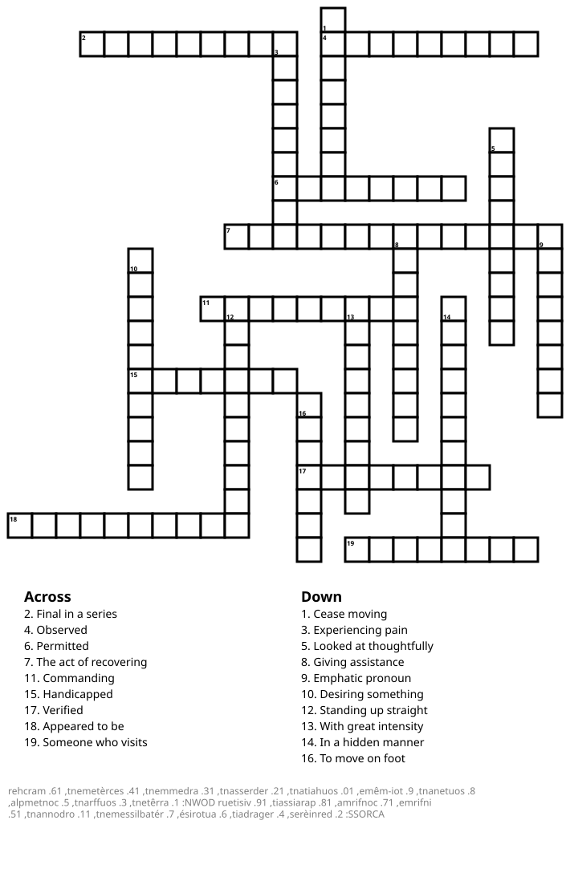

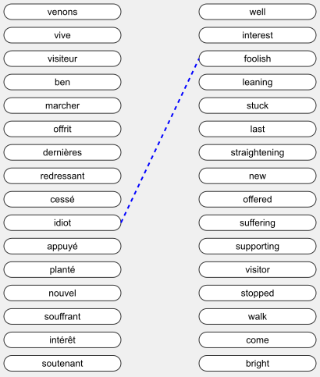

gnitroppus - tnanetuos ,tseretni - têrétni ,gnireffus - tnarffuos ,wen - levuon ,kcuts - étnalp ,gninael - éyuppa ,hsiloof - toidi ,deppots - éssec ,gninethgiarts - tnasserder ,tsal - serèinred ,dereffo - tirffo ,klaw - rehcram ,llew - neb ,rotisiv - ruetisiv ,thgirb - eviv ,emoc - snonev

# Chapter 1.23

Write down any words you need to memorise in the table below. Revisit the list regularly and use each column to tick off the words you have learned in that session. Use the visualisation LLM prompt at the start of the workbook and the 'method of loci' to help imprint the words in your memory. Try writing the words in sentences to help you remember them better.

|  |  |  |  |  |  |  |  |  |  |  |  |  |  |
| --- | --- | --- | --- | --- | --- | --- | --- | --- | --- | --- | --- | --- | --- |
| Word To Learn | ☑ | ☑ | ☑ | ☑ | ☑ | ☑ | ☑ | ☑ | ☑ | ☑ | ☑ | ☑ | ☑ |
|  |  |  |  |  |  |  |  |  |  |  |  |  |  |
|  |  |  |  |  |  |  |  |  |  |  |  |  |  |
|  |  |  |  |  |  |  |  |  |  |  |  |  |  |
|  |  |  |  |  |  |  |  |  |  |  |  |  |  |
|  |  |  |  |  |  |  |  |  |  |  |  |  |  |
|  |  |  |  |  |  |  |  |  |  |  |  |  |  |
|  |  |  |  |  |  |  |  |  |  |  |  |  |  |
|  |  |  |  |  |  |  |  |  |  |  |  |  |  |
|  |  |  |  |  |  |  |  |  |  |  |  |  |  |
|  |  |  |  |  |  |  |  |  |  |  |  |  |  |
|  |  |  |  |  |  |  |  |  |  |  |  |  |  |
|  |  |  |  |  |  |  |  |  |  |  |  |  |  |
|  |  |  |  |  |  |  |  |  |  |  |  |  |  |
|  |  |  |  |  |  |  |  |  |  |  |  |  |  |
|  |  |  |  |  |  |  |  |  |  |  |  |  |  |
|  |  |  |  |  |  |  |  |  |  |  |  |  |  |
|  |  |  |  |  |  |  |  |  |  |  |  |  |  |
|  |  |  |  |  |  |  |  |  |  |  |  |  |  |
|  |  |  |  |  |  |  |  |  |  |  |  |  |  |
|  |  |  |  |  |  |  |  |  |  |  |  |  |  |
|  |  |  |  |  |  |  |  |  |  |  |  |  |  |
|  |  |  |  |  |  |  |  |  |  |  |  |  |  |
|  |  |  |  |  |  |  |  |  |  |  |  |  |  |
|  |  |  |  |  |  |  |  |  |  |  |  |  |  |
|  |  |  |  |  |  |  |  |  |  |  |  |  |  |
|  |  |  |  |  |  |  |  |  |  |  |  |  |  |
|  |  |  |  |  |  |  |  |  |  |  |  |  |  |
|  |  |  |  |  |  |  |  |  |  |  |  |  |  |
|  |  |  |  |  |  |  |  |  |  |  |  |  |  |
|  |  |  |  |  |  |  |  |  |  |  |  |  |  |
|  |  |  |  |  |  |  |  |  |  |  |  |  |  |
|  |  |  |  |  |  |  |  |  |  |  |  |  |  |
|  |  |  |  |  |  |  |  |  |  |  |  |  |  |
|  |  |  |  |  |  |  |  |  |  |  |  |  |  |
|  |  |  |  |  |  |  |  |  |  |  |  |  |  |
|  |  |  |  |  |  |  |  |  |  |  |  |  |  |
|  |  |  |  |  |  |  |  |  |  |  |  |  |  |
|  |  |  |  |  |  |  |  |  |  |  |  |  |  |
|  |  |  |  |  |  |  |  |  |  |  |  |  |  |
|  |  |  |  |  |  |  |  |  |  |  |  |  |  |
|  |  |  |  |  |  |  |  |  |  |  |  |  |  |
|  |  |  |  |  |  |  |  |  |  |  |  |  |  |
|  |  |  |  |  |  |  |  |  |  |  |  |  |  |
|  |  |  |  |  |  |  |  |  |  |  |  |  |  |
|  |  |  |  |  |  |  |  |  |  |  |  |  |  |
|  |  |  |  |  |  |  |  |  |  |  |  |  |  |
|  |  |  |  |  |  |  |  |  |  |  |  |  |  |
|  |  |  |  |  |  |  |  |  |  |  |  |  |  |
|  |  |  |  |  |  |  |  |  |  |  |  |  |  |

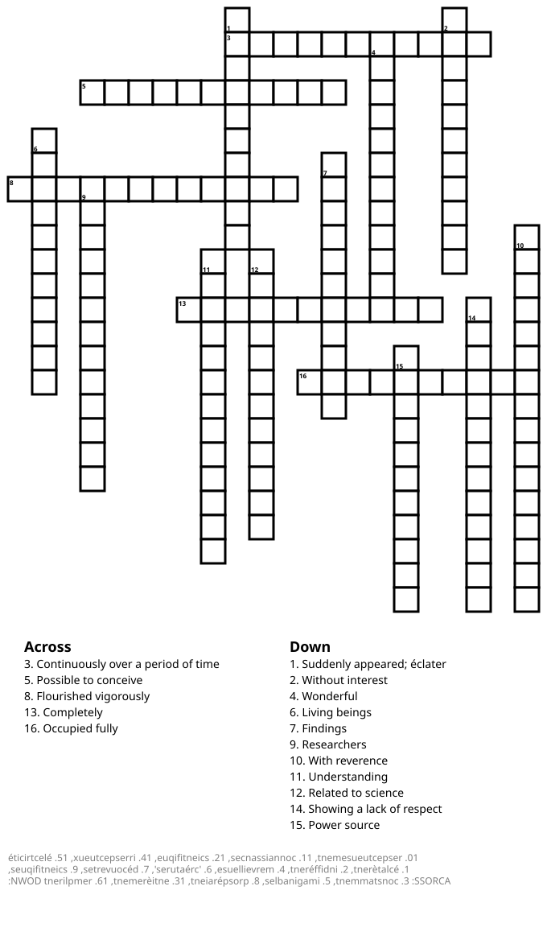

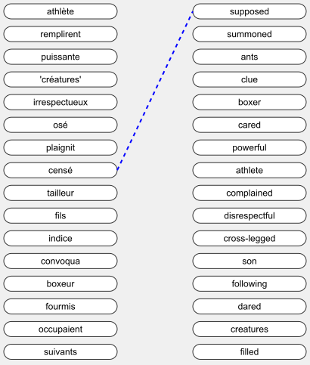

gniwollof - stnavius ,derac - tneiapucco ,stna - simruof ,rexob - ruexob ,denommus - auqovnoc ,eulc - ecidni ,nos - slif ,deggel-ssorc - ruelliat ,desoppus - ésnec ,denialpmoc - tingialp ,derad - éso ,luftcepsersid - xueutcepserri ,serutaerc - 'serutaérc' ,lufrewop - etnassiup ,dellif - tnerilpmer ,etelhta - etèlhta

# Chapter 1.24

Write down any words you need to memorise in the table below. Revisit the list regularly and use each column to tick off the words you have learned in that session. Use the visualisation LLM prompt at the start of the workbook and the 'method of loci' to help imprint the words in your memory. Try writing the words in sentences to help you remember them better.

|  |  |  |  |  |  |  |  |  |  |  |  |  |  |
| --- | --- | --- | --- | --- | --- | --- | --- | --- | --- | --- | --- | --- | --- |
| Word To Learn | ☑ | ☑ | ☑ | ☑ | ☑ | ☑ | ☑ | ☑ | ☑ | ☑ | ☑ | ☑ | ☑ |
|  |  |  |  |  |  |  |  |  |  |  |  |  |  |
|  |  |  |  |  |  |  |  |  |  |  |  |  |  |
|  |  |  |  |  |  |  |  |  |  |  |  |  |  |
|  |  |  |  |  |  |  |  |  |  |  |  |  |  |
|  |  |  |  |  |  |  |  |  |  |  |  |  |  |
|  |  |  |  |  |  |  |  |  |  |  |  |  |  |
|  |  |  |  |  |  |  |  |  |  |  |  |  |  |
|  |  |  |  |  |  |  |  |  |  |  |  |  |  |
|  |  |  |  |  |  |  |  |  |  |  |  |  |  |
|  |  |  |  |  |  |  |  |  |  |  |  |  |  |
|  |  |  |  |  |  |  |  |  |  |  |  |  |  |
|  |  |  |  |  |  |  |  |  |  |  |  |  |  |
|  |  |  |  |  |  |  |  |  |  |  |  |  |  |
|  |  |  |  |  |  |  |  |  |  |  |  |  |  |
|  |  |  |  |  |  |  |  |  |  |  |  |  |  |
|  |  |  |  |  |  |  |  |  |  |  |  |  |  |
|  |  |  |  |  |  |  |  |  |  |  |  |  |  |
|  |  |  |  |  |  |  |  |  |  |  |  |  |  |
|  |  |  |  |  |  |  |  |  |  |  |  |  |  |
|  |  |  |  |  |  |  |  |  |  |  |  |  |  |
|  |  |  |  |  |  |  |  |  |  |  |  |  |  |
|  |  |  |  |  |  |  |  |  |  |  |  |  |  |
|  |  |  |  |  |  |  |  |  |  |  |  |  |  |
|  |  |  |  |  |  |  |  |  |  |  |  |  |  |
|  |  |  |  |  |  |  |  |  |  |  |  |  |  |
|  |  |  |  |  |  |  |  |  |  |  |  |  |  |
|  |  |  |  |  |  |  |  |  |  |  |  |  |  |
|  |  |  |  |  |  |  |  |  |  |  |  |  |  |
|  |  |  |  |  |  |  |  |  |  |  |  |  |  |
|  |  |  |  |  |  |  |  |  |  |  |  |  |  |
|  |  |  |  |  |  |  |  |  |  |  |  |  |  |
|  |  |  |  |  |  |  |  |  |  |  |  |  |  |
|  |  |  |  |  |  |  |  |  |  |  |  |  |  |
|  |  |  |  |  |  |  |  |  |  |  |  |  |  |
|  |  |  |  |  |  |  |  |  |  |  |  |  |  |
|  |  |  |  |  |  |  |  |  |  |  |  |  |  |
|  |  |  |  |  |  |  |  |  |  |  |  |  |  |
|  |  |  |  |  |  |  |  |  |  |  |  |  |  |
|  |  |  |  |  |  |  |  |  |  |  |  |  |  |
|  |  |  |  |  |  |  |  |  |  |  |  |  |  |
|  |  |  |  |  |  |  |  |  |  |  |  |  |  |
|  |  |  |  |  |  |  |  |  |  |  |  |  |  |
|  |  |  |  |  |  |  |  |  |  |  |  |  |  |
|  |  |  |  |  |  |  |  |  |  |  |  |  |  |
|  |  |  |  |  |  |  |  |  |  |  |  |  |  |
|  |  |  |  |  |  |  |  |  |  |  |  |  |  |
|  |  |  |  |  |  |  |  |  |  |  |  |  |  |
|  |  |  |  |  |  |  |  |  |  |  |  |  |  |
|  |  |  |  |  |  |  |  |  |  |  |  |  |  |

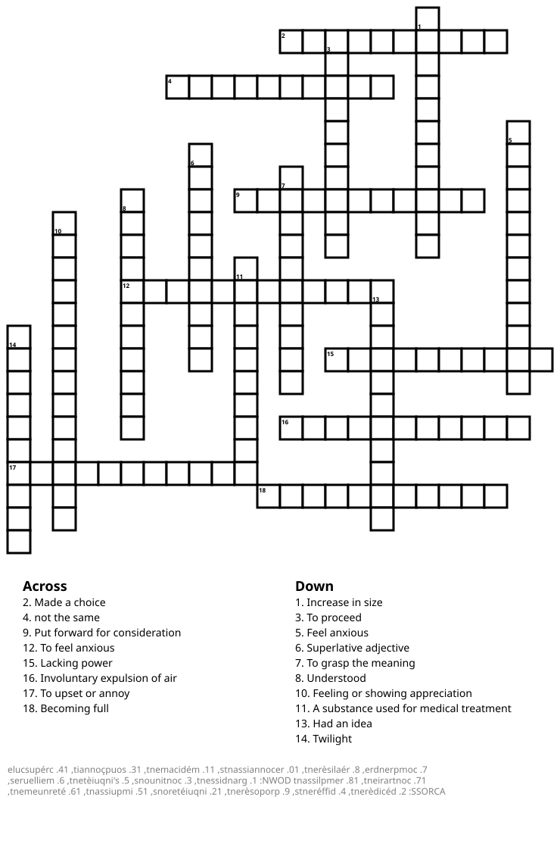

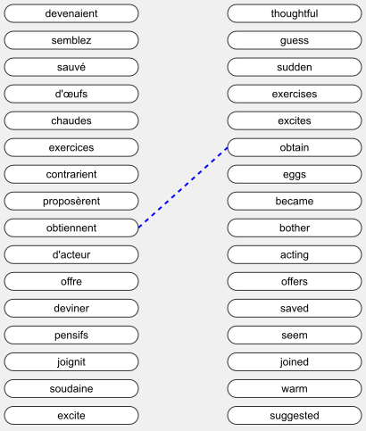

seticxe - eticxe ,neddus - eniaduos ,denioj - tingioj ,lufthguoht - sfisnep ,sseug - renived ,sreffo - erffo ,gnitca - ruetca'd ,niatbo - tnenneitbo ,detseggus - tnerèsoporp ,rehtob - tneirartnoc ,sesicrexe - secicrexe ,mraw - seduahc ,sgge - sfuœ'd ,devas - évuas ,mees - zelbmes ,emaceb - tneianeved

# Chapter 1.25

Write down any words you need to memorise in the table below. Revisit the list regularly and use each column to tick off the words you have learned in that session. Use the visualisation LLM prompt at the start of the workbook and the 'method of loci' to help imprint the words in your memory. Try writing the words in sentences to help you remember them better.

|  |  |  |  |  |  |  |  |  |  |  |  |  |  |
| --- | --- | --- | --- | --- | --- | --- | --- | --- | --- | --- | --- | --- | --- |
| Word To Learn | ☑ | ☑ | ☑ | ☑ | ☑ | ☑ | ☑ | ☑ | ☑ | ☑ | ☑ | ☑ | ☑ |
|  |  |  |  |  |  |  |  |  |  |  |  |  |  |
|  |  |  |  |  |  |  |  |  |  |  |  |  |  |
|  |  |  |  |  |  |  |  |  |  |  |  |  |  |
|  |  |  |  |  |  |  |  |  |  |  |  |  |  |
|  |  |  |  |  |  |  |  |  |  |  |  |  |  |
|  |  |  |  |  |  |  |  |  |  |  |  |  |  |
|  |  |  |  |  |  |  |  |  |  |  |  |  |  |
|  |  |  |  |  |  |  |  |  |  |  |  |  |  |
|  |  |  |  |  |  |  |  |  |  |  |  |  |  |
|  |  |  |  |  |  |  |  |  |  |  |  |  |  |
|  |  |  |  |  |  |  |  |  |  |  |  |  |  |
|  |  |  |  |  |  |  |  |  |  |  |  |  |  |
|  |  |  |  |  |  |  |  |  |  |  |  |  |  |
|  |  |  |  |  |  |  |  |  |  |  |  |  |  |
|  |  |  |  |  |  |  |  |  |  |  |  |  |  |
|  |  |  |  |  |  |  |  |  |  |  |  |  |  |
|  |  |  |  |  |  |  |  |  |  |  |  |  |  |
|  |  |  |  |  |  |  |  |  |  |  |  |  |  |
|  |  |  |  |  |  |  |  |  |  |  |  |  |  |
|  |  |  |  |  |  |  |  |  |  |  |  |  |  |
|  |  |  |  |  |  |  |  |  |  |  |  |  |  |
|  |  |  |  |  |  |  |  |  |  |  |  |  |  |
|  |  |  |  |  |  |  |  |  |  |  |  |  |  |
|  |  |  |  |  |  |  |  |  |  |  |  |  |  |
|  |  |  |  |  |  |  |  |  |  |  |  |  |  |
|  |  |  |  |  |  |  |  |  |  |  |  |  |  |
|  |  |  |  |  |  |  |  |  |  |  |  |  |  |
|  |  |  |  |  |  |  |  |  |  |  |  |  |  |
|  |  |  |  |  |  |  |  |  |  |  |  |  |  |
|  |  |  |  |  |  |  |  |  |  |  |  |  |  |
|  |  |  |  |  |  |  |  |  |  |  |  |  |  |
|  |  |  |  |  |  |  |  |  |  |  |  |  |  |
|  |  |  |  |  |  |  |  |  |  |  |  |  |  |
|  |  |  |  |  |  |  |  |  |  |  |  |  |  |
|  |  |  |  |  |  |  |  |  |  |  |  |  |  |
|  |  |  |  |  |  |  |  |  |  |  |  |  |  |
|  |  |  |  |  |  |  |  |  |  |  |  |  |  |
|  |  |  |  |  |  |  |  |  |  |  |  |  |  |
|  |  |  |  |  |  |  |  |  |  |  |  |  |  |
|  |  |  |  |  |  |  |  |  |  |  |  |  |  |
|  |  |  |  |  |  |  |  |  |  |  |  |  |  |
|  |  |  |  |  |  |  |  |  |  |  |  |  |  |
|  |  |  |  |  |  |  |  |  |  |  |  |  |  |
|  |  |  |  |  |  |  |  |  |  |  |  |  |  |
|  |  |  |  |  |  |  |  |  |  |  |  |  |  |
|  |  |  |  |  |  |  |  |  |  |  |  |  |  |
|  |  |  |  |  |  |  |  |  |  |  |  |  |  |
|  |  |  |  |  |  |  |  |  |  |  |  |  |  |
|  |  |  |  |  |  |  |  |  |  |  |  |  |  |

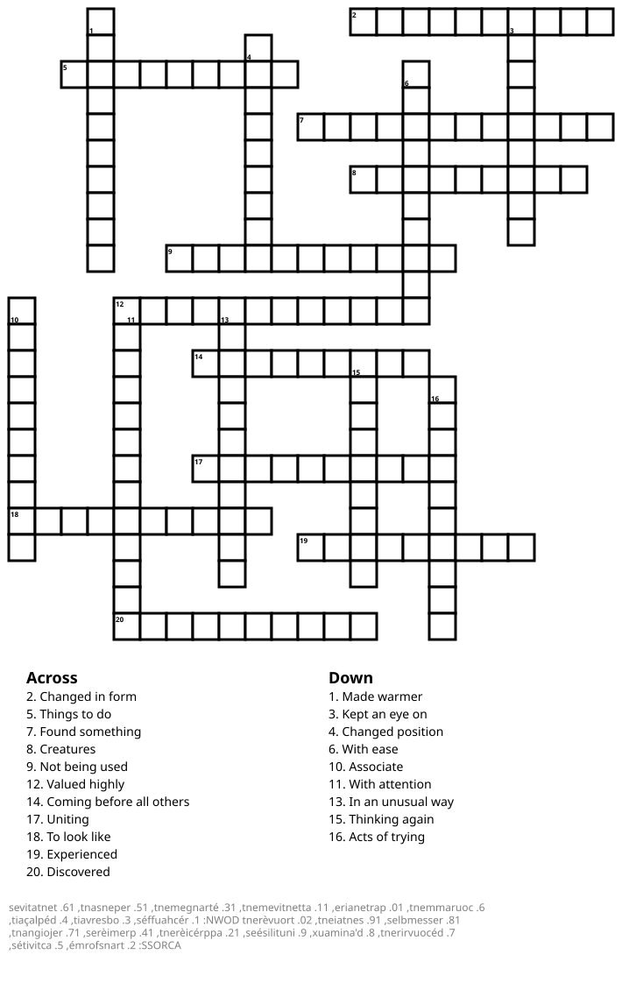

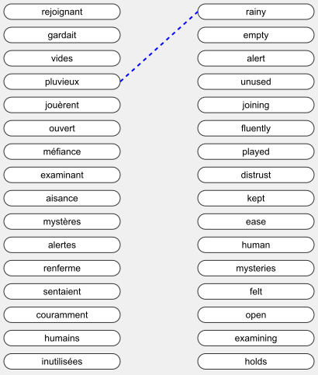

desunu - seésilituni ,namuh - sniamuh ,yltneulf - tnemmaruoc ,tlef - tneiatnes ,sdloh - emrefner ,trela - setrela ,seiretsym - serètsym ,esae - ecnasia ,gninimaxe - tnanimaxe ,tsurtsid - ecnaifém ,nepo - trevuo ,deyalp - tnerèuoj ,yniar - xueivulp ,ytpme - sediv ,tpek - tiadrag ,gninioj - tnangiojer

# Chapter 1.26

Write down any words you need to memorise in the table below. Revisit the list regularly and use each column to tick off the words you have learned in that session. Use the visualisation LLM prompt at the start of the workbook and the 'method of loci' to help imprint the words in your memory. Try writing the words in sentences to help you remember them better.

|  |  |  |  |  |  |  |  |  |  |  |  |  |  |
| --- | --- | --- | --- | --- | --- | --- | --- | --- | --- | --- | --- | --- | --- |
| Word To Learn | ☑ | ☑ | ☑ | ☑ | ☑ | ☑ | ☑ | ☑ | ☑ | ☑ | ☑ | ☑ | ☑ |
|  |  |  |  |  |  |  |  |  |  |  |  |  |  |
|  |  |  |  |  |  |  |  |  |  |  |  |  |  |
|  |  |  |  |  |  |  |  |  |  |  |  |  |  |
|  |  |  |  |  |  |  |  |  |  |  |  |  |  |
|  |  |  |  |  |  |  |  |  |  |  |  |  |  |
|  |  |  |  |  |  |  |  |  |  |  |  |  |  |
|  |  |  |  |  |  |  |  |  |  |  |  |  |  |
|  |  |  |  |  |  |  |  |  |  |  |  |  |  |
|  |  |  |  |  |  |  |  |  |  |  |  |  |  |
|  |  |  |  |  |  |  |  |  |  |  |  |  |  |
|  |  |  |  |  |  |  |  |  |  |  |  |  |  |
|  |  |  |  |  |  |  |  |  |  |  |  |  |  |
|  |  |  |  |  |  |  |  |  |  |  |  |  |  |
|  |  |  |  |  |  |  |  |  |  |  |  |  |  |
|  |  |  |  |  |  |  |  |  |  |  |  |  |  |
|  |  |  |  |  |  |  |  |  |  |  |  |  |  |
|  |  |  |  |  |  |  |  |  |  |  |  |  |  |
|  |  |  |  |  |  |  |  |  |  |  |  |  |  |
|  |  |  |  |  |  |  |  |  |  |  |  |  |  |
|  |  |  |  |  |  |  |  |  |  |  |  |  |  |
|  |  |  |  |  |  |  |  |  |  |  |  |  |  |
|  |  |  |  |  |  |  |  |  |  |  |  |  |  |
|  |  |  |  |  |  |  |  |  |  |  |  |  |  |
|  |  |  |  |  |  |  |  |  |  |  |  |  |  |
|  |  |  |  |  |  |  |  |  |  |  |  |  |  |
|  |  |  |  |  |  |  |  |  |  |  |  |  |  |
|  |  |  |  |  |  |  |  |  |  |  |  |  |  |
|  |  |  |  |  |  |  |  |  |  |  |  |  |  |
|  |  |  |  |  |  |  |  |  |  |  |  |  |  |
|  |  |  |  |  |  |  |  |  |  |  |  |  |  |
|  |  |  |  |  |  |  |  |  |  |  |  |  |  |
|  |  |  |  |  |  |  |  |  |  |  |  |  |  |
|  |  |  |  |  |  |  |  |  |  |  |  |  |  |
|  |  |  |  |  |  |  |  |  |  |  |  |  |  |
|  |  |  |  |  |  |  |  |  |  |  |  |  |  |
|  |  |  |  |  |  |  |  |  |  |  |  |  |  |
|  |  |  |  |  |  |  |  |  |  |  |  |  |  |
|  |  |  |  |  |  |  |  |  |  |  |  |  |  |
|  |  |  |  |  |  |  |  |  |  |  |  |  |  |
|  |  |  |  |  |  |  |  |  |  |  |  |  |  |
|  |  |  |  |  |  |  |  |  |  |  |  |  |  |
|  |  |  |  |  |  |  |  |  |  |  |  |  |  |
|  |  |  |  |  |  |  |  |  |  |  |  |  |  |
|  |  |  |  |  |  |  |  |  |  |  |  |  |  |
|  |  |  |  |  |  |  |  |  |  |  |  |  |  |
|  |  |  |  |  |  |  |  |  |  |  |  |  |  |
|  |  |  |  |  |  |  |  |  |  |  |  |  |  |
|  |  |  |  |  |  |  |  |  |  |  |  |  |  |
|  |  |  |  |  |  |  |  |  |  |  |  |  |  |

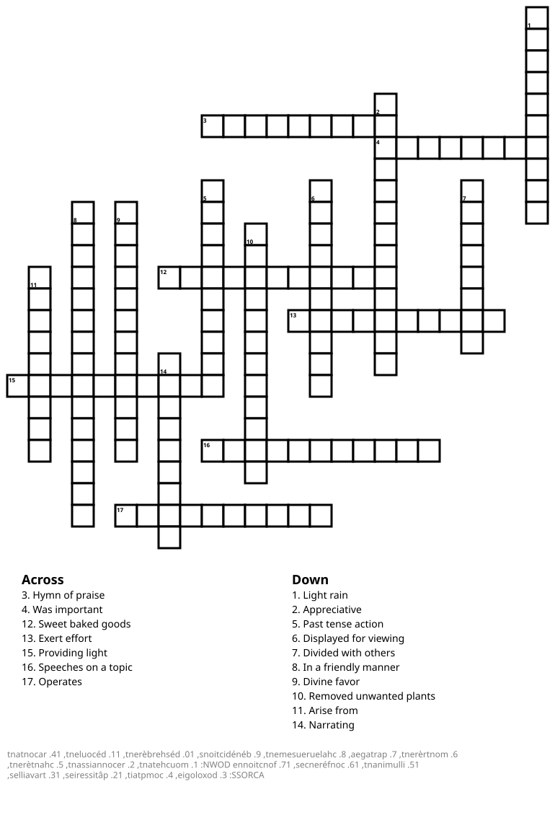

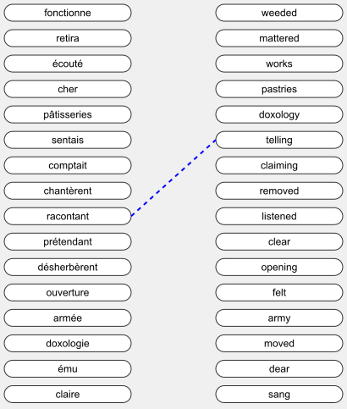

raelc - erialc ,devom - umé ,ygoloxod - eigoloxod ,ymra - eémra ,gninepo - erutrevuo ,dedeew - tnerèbrehséd ,gnimialc - tnadnetérp ,gnillet - tnatnocar ,gnas - tnerètnahc ,derettam - tiatpmoc ,tlef - siatnes ,seirtsap - seiressitâp ,raed - rehc ,denetsil - étuocé ,devomer - ariter ,skrow - ennoitcnof

# Chapter 1.27

Write down any words you need to memorise in the table below. Revisit the list regularly and use each column to tick off the words you have learned in that session. Use the visualisation LLM prompt at the start of the workbook and the 'method of loci' to help imprint the words in your memory. Try writing the words in sentences to help you remember them better.

|  |  |  |  |  |  |  |  |  |  |  |  |  |  |
| --- | --- | --- | --- | --- | --- | --- | --- | --- | --- | --- | --- | --- | --- |
| Word To Learn | ☑ | ☑ | ☑ | ☑ | ☑ | ☑ | ☑ | ☑ | ☑ | ☑ | ☑ | ☑ | ☑ |
|  |  |  |  |  |  |  |  |  |  |  |  |  |  |
|  |  |  |  |  |  |  |  |  |  |  |  |  |  |
|  |  |  |  |  |  |  |  |  |  |  |  |  |  |
|  |  |  |  |  |  |  |  |  |  |  |  |  |  |
|  |  |  |  |  |  |  |  |  |  |  |  |  |  |
|  |  |  |  |  |  |  |  |  |  |  |  |  |  |
|  |  |  |  |  |  |  |  |  |  |  |  |  |  |
|  |  |  |  |  |  |  |  |  |  |  |  |  |  |
|  |  |  |  |  |  |  |  |  |  |  |  |  |  |
|  |  |  |  |  |  |  |  |  |  |  |  |  |  |
|  |  |  |  |  |  |  |  |  |  |  |  |  |  |
|  |  |  |  |  |  |  |  |  |  |  |  |  |  |
|  |  |  |  |  |  |  |  |  |  |  |  |  |  |
|  |  |  |  |  |  |  |  |  |  |  |  |  |  |
|  |  |  |  |  |  |  |  |  |  |  |  |  |  |
|  |  |  |  |  |  |  |  |  |  |  |  |  |  |
|  |  |  |  |  |  |  |  |  |  |  |  |  |  |
|  |  |  |  |  |  |  |  |  |  |  |  |  |  |
|  |  |  |  |  |  |  |  |  |  |  |  |  |  |
|  |  |  |  |  |  |  |  |  |  |  |  |  |  |
|  |  |  |  |  |  |  |  |  |  |  |  |  |  |
|  |  |  |  |  |  |  |  |  |  |  |  |  |  |
|  |  |  |  |  |  |  |  |  |  |  |  |  |  |
|  |  |  |  |  |  |  |  |  |  |  |  |  |  |
|  |  |  |  |  |  |  |  |  |  |  |  |  |  |
|  |  |  |  |  |  |  |  |  |  |  |  |  |  |
|  |  |  |  |  |  |  |  |  |  |  |  |  |  |
|  |  |  |  |  |  |  |  |  |  |  |  |  |  |
|  |  |  |  |  |  |  |  |  |  |  |  |  |  |
|  |  |  |  |  |  |  |  |  |  |  |  |  |  |
|  |  |  |  |  |  |  |  |  |  |  |  |  |  |
|  |  |  |  |  |  |  |  |  |  |  |  |  |  |
|  |  |  |  |  |  |  |  |  |  |  |  |  |  |
|  |  |  |  |  |  |  |  |  |  |  |  |  |  |
|  |  |  |  |  |  |  |  |  |  |  |  |  |  |
|  |  |  |  |  |  |  |  |  |  |  |  |  |  |
|  |  |  |  |  |  |  |  |  |  |  |  |  |  |
|  |  |  |  |  |  |  |  |  |  |  |  |  |  |
|  |  |  |  |  |  |  |  |  |  |  |  |  |  |
|  |  |  |  |  |  |  |  |  |  |  |  |  |  |
|  |  |  |  |  |  |  |  |  |  |  |  |  |  |
|  |  |  |  |  |  |  |  |  |  |  |  |  |  |
|  |  |  |  |  |  |  |  |  |  |  |  |  |  |
|  |  |  |  |  |  |  |  |  |  |  |  |  |  |
|  |  |  |  |  |  |  |  |  |  |  |  |  |  |
|  |  |  |  |  |  |  |  |  |  |  |  |  |  |
|  |  |  |  |  |  |  |  |  |  |  |  |  |  |
|  |  |  |  |  |  |  |  |  |  |  |  |  |  |
|  |  |  |  |  |  |  |  |  |  |  |  |  |  |

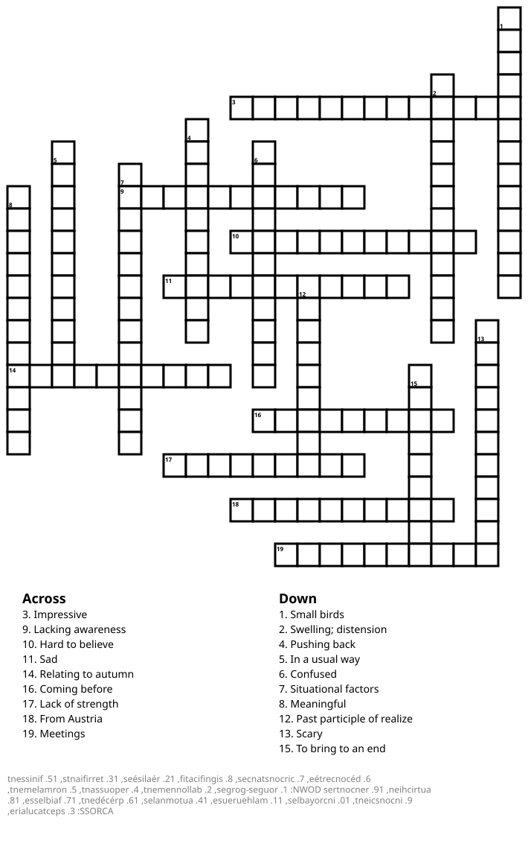

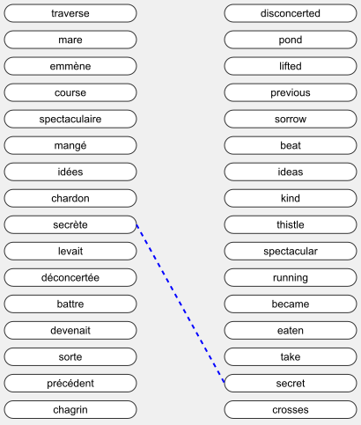

worros - nirgahc ,suoiverp - tnedécérp ,dnik - etros ,emaceb - tianeved ,taeb - erttab ,detrecnocsid - eétrecnocéd ,detfil - tiavel ,terces - etèrces ,eltsiht - nodrahc ,saedi - seédi ,netae - égnam ,ralucatceps - erialucatceps ,gninnur - esruoc ,ekat - enèmme ,dnop - eram ,sessorc - esrevart